SAVE DOLLARS ON DIAPERS
Smart Strategies for Slashing Diaper Costs from Infancy to Potty Training

Save Dollars on Diapers
Copyright © 2014 by Sandra J. Gordon
All rights reserved. No part of this publication may be reproduced, stored in a retrieval system, or transmitted by any means—electronic, mechanical, photographic (photocopying), recording, or otherwise—without prior permission in writing from the author.
Printed in the United States of America
ISBN-13: 978-1503166301
ISBN-10: 1503166309

AVE DOLLARS
ON DIAPERS

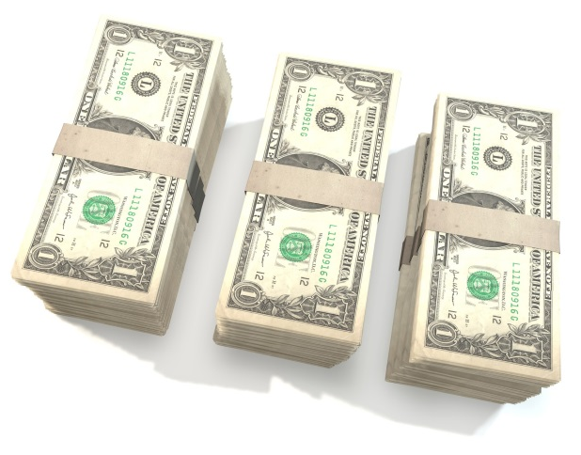

Smart Strategies for Slashing Diaper Costs from Infancy to Potty Training

Sandra J. Gordon

Contents
Introduction 7
Saving Money on Diaper Duty 7
Chapter One 11
Butt First: 11
Disposables—a Background Check 11
What’s Really in a Disposable? 12
Rash Talkin’ 14
A Rash of Additional Facts 16
Are You a Candidate for Disposable Diapers? 17
Reasons to Choose Disposables 18
What’s Available 19
Diaper Developments 20
Chapter Two 23
Saving on Disposables 23
Diaper Data 25
Chapter Three 51
Join the Cloth Diaper Revolution 51
The Cuteness Factor 53
What’s Available 54
Sweat Equity 54
Cloth Diaper Choices 56
Moderately-priced and user friendly: 60
Soaker 62
The Daycare Dilemma 64
Hybrid Diapers: 65
Chapter Four 71
Product Spotlight: Tidy Tots—the Cloth Diaper Reinvented
Chapter Five 75
Saving on Cloth and Hybrid Diapers 75
Chapter Six 83
Caring for Cloth Diapers and Preserving Your Investment 83
Chapter Seven 91
Diapers for Rock-bottom Budgets 91
Chapter Eight 97
Save Space: Pack Lighter with 97
Diaper Buds 97
Chapter Nine 99
Diaper Safety Savvy 99
“China Cheapies” 100
Diaper To-Do List 101
About the Author 104

Introduction

Saving Money on Diaper Duty
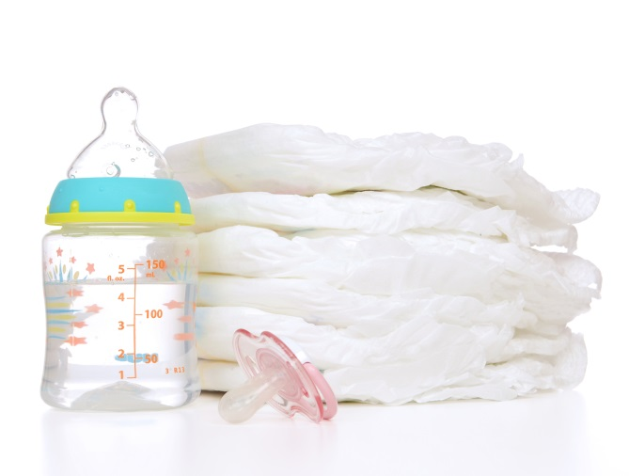

C
ongratulations! You’re having a baby (or babies). It’s a life-changing experience that’s filled with joy and, of course, its fair share of diaper duty. In fact, according to the Juvenile Products Manufacturers Association (JPMA), you’ll change diapers 3,000 times in your baby’s first year alone! And get this: Babies typically go through roughly 7,000 disposable diapers from birth to potty training.
Little ones come with big expenses and disposable diapers can take a big chunk of the family budget. The outlay is right up there with the cost of infant formula, which is another major money grabber. In the U.S. alone, parents and other caregivers collectively spend roughly $6 billion on diapers, wipes and baby personal care products. Companies, such as Kimberly-Clark (Huggies) and Proctor & Gamble (Pampers and Luvs), control 65 percent of the business due to their strength in the diapers and wipes sector. Manu-facturers like these and retailers want to sell more diapers. Meanwhile, consumers are looking harder than ever for the best deals on diapers. The upshot? There has never been a better time to get great diaper deals.
In today’s deal culture, which is driven by economic condi-tions and market competition spurred on by social media, you’re not just pushing your shopping cart through the baby superstore, you’re wheelin’ and dealin’. In this book, I’ll help you learn how to save money on whatever type of diaper you decide to use—disposable or cloth, which are becoming increasingly popular and themselves a major money saver, or hybrids (a mix of the two).
If you ultimately decide to use disposable diapers—like the majority of parents do even though reusable diapers are becoming more mainstream--you can anticipate spending an average of $80 per month, for a total cost of around $2,500 from birth to potty training (at around age 2 1/2). But you can spend less than that—a lot less. Trying to reduce your diaper overhead is a smart move. The $2,500 you’d otherwise shell out on disposables during your baby’s diapering career amounts to only about $20 per week per baby. But speaking from experience, it can feel like a lot more than that. Confession: I changed diapers for a total of five consecutive years when my two girls were little. My husband gagged the one time he changed my oldest daughter’s diaper and that was it for him, so diaper duty was all mine and somehow, I really didn’t mind. But the cost? Ouch! When my second daughter, Amelia, turned 2, I remember anticipating how much more money I was going to have when she was potty trained. If she followed her older sister, Rebecca’s timetable, I anticipated just six more months of diaper buying. Now that was cause for celebration! Money was especially tight back then (at the time, my husband was a commercial real estate broker on 100 percent commission and closing deals proved as elusive as ever) and that $160 per month diaper tab (for two munchkins in diapers) felt as taxing as another mortgage payment, especially when we soon had them both in half-day daycare/preschool at the local YMCA so I could cram a day’s worth of writing into a kid-free morning five days per week.
For years, including when my daughters were in diapers, buying store-brand disposables and using coupons were the biggest ways you could shave a little off your diaper bill. But the recession changed all that. As a result of the valuable economic learning experience it necessitated, and social media, we’re more resourceful, strategic and calculating than ever about shopping and less driven by impulse, advertising and the cache of name brands. That’s a good thing. In short, shopping has become more of a game consumers can win.
Demand for less expensive and eco-friendly diaper choices (more on those later) has driven manufacturers and retailers to create budget-friendly innovative diapering solutions and offer more competitive discounts. How can you save on this must-have baby basic? Which type of diaper should you use? Read on to get the lay of today’s diaper land and the poop on the various ways to save on this very baby basic.

Chapter One

Butt First:

Disposables—a Background Check
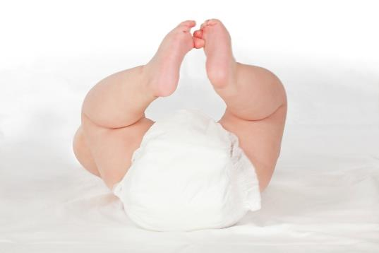
B
efore the 1960s, cloth diapers—the kind I know my grandmother used, with pins and crinkly plastic pants--were the only option. Then, disposables came on the scene, along with feminism and convenience food, revolutionizing baby waste management. Now, cloth diapers, the next generation, a.k.a. reusable diapers, are making a comeback, giving disposable diapers a run for their money. As a result, the options in diapers are dizzying, including disposables, cloth and hybrids, which are a mix of the two.
Despite the recession and the “green” movement, dispos-ables are still the most popular-selling diaper, according to Carlos Richer, a diaper industry consultant and owner of Disposablediaper.net. Ninety-six percent of parents with infants and toddlers in the U.S. use them, as do a similar percentage of parents in Germany, Spain, The Netherlands and Finland.
If you decide to go the disposable diaper route at least some of the time, it’s nice to know what you’re buying. In this chapter, I’ll focus on the inside story. I’ll fill you in on what mainstream disposable diapers are filled with and why disposables might be the way to go. If you want to get right into the money-saving aspects, feel free to swipe to the next chapter.

What’s Really in a Disposable?
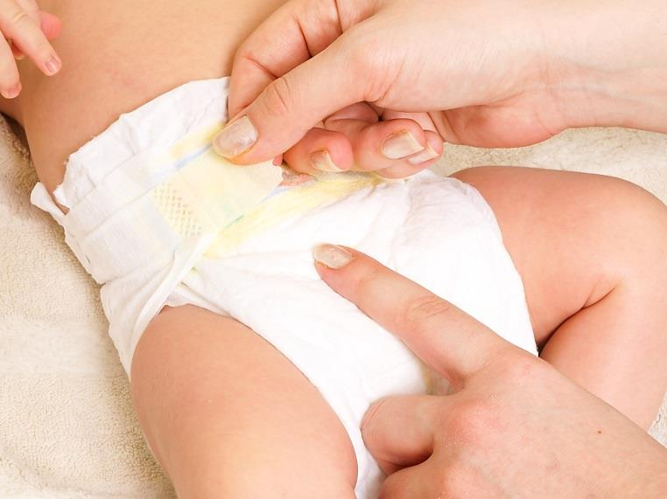
A disposable diaper is more complicated than you might think. It’s comprised of an absorbent core sandwiched between an inner soft nonwoven synthetic propylene/ polyethylene top sheet, which is directly against a baby’s bottom, and a water-resistant, cloth-like back sheet, which is what the world sees. Want to know more? Here’s a break-down of the various components.
The top sheet
Working from the inside out, this is the layer in the core of the diaper that’s directly against your baby’s skin. It quickly absorbs urine and spreads it across the core of the diaper and allows liquids to pass through to the thick layers beneath while remaining relatively dry and soft. It may contain lotion to protect baby’s skin from irritation and wetness.
Acquisition/distribution layer
This is the next layer in the disposable diaper sandwich. It’s typically made of modified cellulose and polyester, which are specially designed fibers that are embedded beneath the top sheet to absorb and pull liquid into the next layer, away from a baby’s skin.
The absorbent core
This next, innermost layer is a disposable diaper’s storage area. It consists of absorbent gelling materials (AGMs, for short), the “super absorber” widely used in disposables today, and cellulose pulp housed in a cellulose or polypropylene nonwoven layer. AGMs, which exist in dry diapers as small, transparent crystals, can absorb up to 200 times their weight in liquid, which is why a diaper can feel like a bag of cement when it’s wet. AGMs soak up and lock fluid into the diaper’s core. Because of this conceptual advancement, disposables can keep liquid away from a baby’s skin (a concept known as “rewetting), even under pressure, such as when a baby is sitting on a full diaper. Because of AGMs, you can also leave a baby in a disposable diaper longer than in a cloth diaper without risking diaper rash. Of course, it’s best to change your baby as soon as he has a dirty or wet diaper, but with all you’ve got going on, that’s not always possible.
The back layer, the back sheet
This is a water-resistant polyethylene (plastic) film laminated with a soft-textured, cloth-like polypropylene (plastic), which prevents liquid from leaking.
Each diaper layer is considered safe, even if a baby accidentally chews on a diaper. Keep diapers out of your baby’s reach nonetheless. Shopping strategy: If you’re in the market for a changing table, look for one with drawers rather than one with open shelving so you can hide your baby’s diapers and other changing supplies. An open inventory of diapers and supplies can be tempting to a curious toddler--in other words, your baby in no time.
That’s the inside story. Overall, today’s disposables showcase the science of absorbency. Because of the gel matrix and other engineered components, disposable diapers aren’t just a convenience item. According to a study in Regulatory Toxicology and Pharmacology sponsored by Procter & Gamble (the makers of Pampers and Luvs), they’re a product that “improves the comfort and skin health of the infant.”

Rash Talkin’
Dermatologists, such as Ilona J. Frieden, M.D., director of pediatric dermatology at the University of California San Francisco Benioff Children’s Hospital, a world-renowned specialist in children's skin diseases, would agree. “Disposable diapers have some real advantages for children who have problems with rashes in the diaper area. The most important is that the diaper is super absorbent. The gel matrix is able to absorb so much more and keep the area much drier than a cloth diaper can, even if it’s promptly changed.” Diaper rash, the skin eruption in the diaper area, a.k.a. diaper dermatitis, was once considered a problem virtually all infants experienced. Studies beginning in the 1980s, however, have demonstrated that disposable diapers could keep a baby’s skin dryer and closer to its normal protective pH level than cloth diapers because the gel crystals in the inner core held liquid away from a baby’s skin.
As a result of disposable diaper advancements, some disposable-diapered babies, my daughters once among them, don’t have even one episode of diaper rash. Rash incidence has declined in conjunction with disposable diaper technology. Still, according to an article in Clinical Pediatrics, up to one third of infants may exhibit clinical symptoms of diaper rash at any one time, and more than half of babies between the ages of 4 and 15 months develop diaper rash at least once in a two-month period. The length of time a baby’s bottom is in contact with urine and/or poop is a major factor. The dark, warm and damp environment in a diaper raises the pH level of the skin, making it more alkaline and vulnerable to irritating fecal enzymes. Moreover, feces contain bile salts and other irritants that break down the protective fats and proteins that exist in the skin’s top layer. Urine releases ammonia when it breaks down, which also raises the skin’s pH. Consequently, a mix of pee and poop is a double whammy, making a baby’s bottom especially susceptible to chemical irritation. Pee and poop can elevate the skin’s pH levels that in turn, can activate the fecal enzymes that may cause rash and redness.
Prevention is key. According to studies, not keeping a baby clean and dry is the biggest contributing factor to diaper rash, followed by (not necessarily in this order) diarrhea, not drinking enough, infections, certain medications like antibiotics, diet, warmth and humidity, and sitting.

A Rash of Additional Facts
The peak age for irritant diaper rash is 9 months, when solids are a sure thing on the menu and have been for several months. Solid food changes fecal enzymes to make diaper rash more likely.
Breast-fed babies are less prone to diaper rash, especially before they transition to solids, because their diaper area is naturally more acidic and less alkaline.
Diaper rash isn’t seasonal. Babies aren’t likely to experience it more in the summer than in the winter.
All told, disposable diapers help prevent diaper rash, but some babies are also just more prone to diaper rash period. Their skin is more sensitive or the barrier of their skin isn’t as protective. “In a child who has recurrent rashes, change him more often,” Dr. Frieden says. If your baby gets diaper rash anyway, the American Academy of Pediatrics offers solutions, which include keeping the area as clean and dry as possible.

Are You a Candidate for Disposable Diapers?
Pros: Disposable diapers can do a good job of keeping diaper rash at bay. They’re absorbent, yet wick moisture away from baby’s skin, making a baby less susceptible to diaper rash, so you don’t need to change diapers as often as you do when a baby wears reusable diapers. They’re convenient too. There’s nothing like just plunging a dirty diaper in the Diaper Genie, which is the last stop before the actual trashcan, and being done with it. Bye! Plus, there’s no learning curve. Disposable diapers are easy to use from day one.
Con: You’ll pay for the ease and convenience, up to 46 cents per diaper, or more for niche diapers, such a biodegradable or “hypoallergenic” ones. You have to buy different sizes as your baby grows too. As your baby’s disposable diaper size increases, the more you’ll shell out per diaper.
Con: There’s also, ahem, the environmental factor. Let’s face it--disposable diapers aren’t known to be great for the environment. They occupy approximately 2 percent of landfill space, according to study in the American Journal of Public Health, which doesn’t sound like much. But it takes 450 years for a regular disposable diaper to disintegrate in a landfill, the same amount of time it takes for a plastic bottle to break down, according to the United States Environmental Protection Agency (EPA).
The good news: Today’s disposable diapers are generally “greener” and use fewer resources to produce. They may use fainter print, which requires less ink or ink that’s not derived from heavy metals. They may be processed without chlorine or “harsh chemicals.” They may also contain organic cotton in the cover and be manufactured from renewable, plant-based materials, such as wood pulp, corn and wheat-derived filler, or seed oil to reduce the use of non-renewable petrochemicals and biodegrade faster. According to the EPA, an actual “biodegradable” disposable diaper takes just one year to degrade, equal to the time it takes for a piece of plywood to melt back into the earth.

Reasons to Choose Disposables
Disposable diapers are a logical choice for many parents, at least some of the time, especially if you:
- Value ease and convenience and don’t mind paying for it.
- Have a baby attending a daycare center that only accepts disposable diapers.
- Just don’t want to deal with reusable diapers, which I discuss in Chapter Three.
- Don’t have ready access to a washing machine. If you’re a laundromat user or you must trudge to the laundry room in your apartment building and wait in line for use of the machines, for example, disposables could be a more convenient choice for you.
- Travel a lot with your baby, or even just a little. Disposables make sense when you don’t have ready access to a diaper disposal or a washing machine. Parents who use cloth diapers have been known to switch to disposable diapers when they’re on the road or the air with their baby.
Even if you plan to use cloth diapers, you might consider disposable diapers, especially in the beginning. “Only the most devout cloth diaper wearers will start their baby in cloth diapers from day one,” says Kate Cross, a 37-year-old mom of three from Mechanicville, New York, who started using cloth diapers with baby number two, but not until he was 6 months old. She used cloth diapers again with her third child, but waited until he was 3 months old. Why? “Newborns are prone to overwhelming diaper blow-outs that no cloth diaper can contain,” she says.
Another plus for disposables, at least at the onset: They can help save your sanity. As you may know, thriving infants are expected to produce six to eight wet diapers and two to five “dirty” diapers daily during their first four months. You’ll change a maximum of 13 daily diapers in the first 45 days, which is more than one diaper swap per hour in a 24-hour new parent’s day. That impressive diaper output signals babies are getting enough breast milk or formula, which is the only thing on the menu at that point. Disposable diapers can make this near-constant-diaper-changing period easier.

What’s Available
Popular name brands of disposable diapers include: Bambo Nature, Earth’s Best, Huggies, Luvs, Nature Babycare, Pampers, The Honest Company and Seventh Generation.
Roughly 50 percent of diaper buyers consider themselves to be name-brand loyal, according to privatelabelbuyer.com. If you’re open to store brands/private label diapers, however, you have lots more options. You can find store-brand disposables at BabiesRUs (BabiesRUs brand), CVS (CVS), CostCo (Kirkland), Kroger (Comforts for Baby and Comforts Touch of Nature), Sam’s Club (Simply Right), Target (Up & Up), Walgreens (Walgreens Premium) and Walmart (Parent’s Choice).
Store brand/private-label diapers also regionally available at Albertson’s (Baby Basics brand), BJs (Berkley & Jensen), Dominick’s (Mom to Mom), Food Lion (Home 360 Baby), Fred Meyer (Comforts), H-E-B (H-E-B Baby), HyVee (Mother’s Choice), Ralphs (Comforts for Baby), Randalls (Mom to Mom), Rite Aid (Tugaboos), Safeway (Mom to Mom), Shopko (Shopko), Stop & Shop (Cottontails), Tom Thumb (Mom to Mom) and Wegman’s (Wegman’s), among other retailers.

Diaper Developments
Disposable diapers have come a long way since their inception, and they continue to evolve, doing an even better job of containing the chaos. Some of the latest disposable advances among all types of disposables include better absorbency using less bulk, materials that “breathe” and feel cloth-like, flexible side panels for a closer fit to prevent leaks, a stretchy waistband for comfort, a contoured shape so baby can move around better and a wetness indicator, which changes color when a baby wets. Is a wetness indicator necessary or just a marketing ploy? It depends on who you ask. At CVS recently, the check-out line meandered into the disposable diaper aisle. There, I found myself standing next to an older woman eyeing a diaper package. “If today’s parents need wetness indicators, they shouldn’t be raising kids,” she said. Humph! She also revealed that her grown kids hadn’t yet made her a grandmother. I just smiled.
I would argue (but I didn't) that wetness indicators can be useful. Even experienced parents can’t always tell when a baby’s diaper is wet. Wetness indicators can help prevent you from changing a dry diaper, which saves money because once you take a disposable diaper off, it’s done. You can’t easily retape it, though I certainly tried.
Other features you’ll benefit from with disposable diapers include overlapping fastening systems for a more flexible fit and an umbilical cord notch in newborn diapers, which provides space in the belly button area. Some diapers also offer helpful design elements, such as graphics that guide the placement of the adhesive tabs.
Many disposables, such as Bambo Nature, Fisher Price, Huggies Pure & Natural, Pampers Sensitive, Seventh Generation and The Honest Company, are marketed to be healthier for your baby too. They may be “hypoallergenic” and made without “harsh chemicals,” and “Gentle, safe, and non-irritating for the most sensitive skin.” They typically contain no scent, perfumes, oils, heavy metals, chlorine or phthalates, which is a component of plastic to make it flexible.
If you choose disposable diapers at least part of the time, the next chapter can help you buy them for less. Switching to the store brand is one of the first things you might try, but as you’ll see, there are more ways to save on disposable diapers than bees at a picnic.
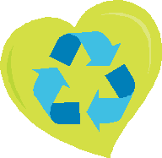
Package Pointer: Whether you choose biodegradable diapers or not, recycling the packaging is another way to green your scene. You can recycle the packaging through TerraCycle, an organization that repurposes cardboard packaging into new, innovative materials and products. TerraCycle requires consumers to team up with others through national programs called “Brigades” to collect previously non-recyclable or hard to recycle waste. In addition to consumers, TerraCycle works with more than 100 major brands, such as Huggies and Earth’s Best, in the U.S. and 22 countries overseas to collect used packaging and products that would otherwise be destined for landfills. For more information, visit Terracycle.com.

Chapter Two

Saving on Disposables
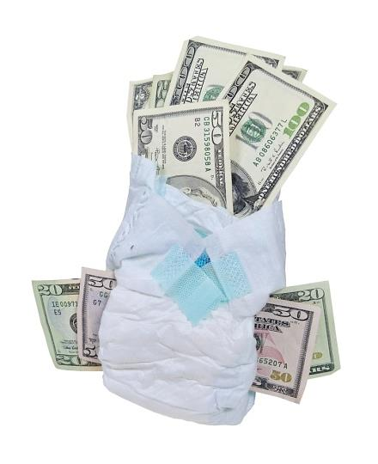
N
ow that you know what today’s disposable diapers are all about, it’s time to get the best deal. Let’s start with sizing.
Disposable diapers are typically sized according to baby/ toddler weight, beginning with preemie (up to 6 pounds) and newborn (up to 10 pounds) followed by sizes 1 (up to 14 pounds), 2 (12 to 18 pounds), 3 (16 to 18 pounds), 4 (22 to 27 pounds), 5 (27+ pounds) and 6 (35+ pounds) or 7 (41+ pounds). Diaper sizes are similar among brands. Some store and “eco-friendly” disposable brands, though, are marked simply small, medium, large, and extra-large, and weight ranges are listed on the package. As the sizes increase, you get fewer diapers for the same price. A large package might give you 72 diapers in size 1, but only 40 in size 6. As with many things, buying in quantity can reduce your per-diaper costs.
To reduce your disposable diaper costs, don’t be too quick to jump to the next-size diaper. Huggies Snug & Dry disposables might cost you 16 cents per diaper in size 1, for example, and 36 cents per diaper in size 6. In general, keep your baby in the smallest size diaper he can comfortably wear for as long as possible, within the weight guidelines on the package. Here are 18 more ways to save on disposable diapers.
#1 Supersize it
In the world of disposable diaper savings, supersize boxes rule. You’ll pay less per diaper the larger the package you can lug home. For example, you’ll save roughly 6 cents per diaper by buying the Extra Large Case of Size 3 Pampers Cruisers (160 diapers) compared to buying Size 3 Cruisers in the Jumbo Pack (35 diapers). Similarly, a 31 count of Pampers Baby Dry in size 4 will run you about 32 cents per diaper, for example, but you’ll only pay about 24 cents per diaper if you buy the size 4 in the 140 count package. The likes of a 6 or 8 cent savings per diaper aren’t much, but hey, it adds up!
A timing note: Buying in bulk (the big box) makes the most sense when you know you like the diaper, your baby has just moved up to a new size, your baby is wearing size 5 or 6 or you’ve got multiples (twins or triplets). Otherwise, you might get stuck with a bunch of diapers you don’t like. Your baby could also outgrow the diaper size before you’ve emptied the “giga” box. There’s a secondhand market for opened or unopened boxes of diapers (unopened is better) but buying the right number of diapers will save you that hassle.

Diaper Data
To help you gauge the disposable diaper quantity you’ll need and when to buy in bulk, here’s diaper data that can help. According to DiaperDecisions.com, babies are likely to spend:
--Two weeks in newborn disposable diapers
--10 weeks in size 1 diapers
--12 weeks in sizes 2, 3, and 4
--24 weeks in size 5
--48 weeks in size 6
Based on those estimates, here’s the number diapers you’ll need per baby.
--Newborn diapers: 195
--Size 1, 775
--Size 2, 925
--Size 3, 750
--Size 4, 590
--Size 5, 1175
--Size 6, 2350
Total: 6,760!
Keep these figures in mind when planning your diaper buys. They’re just a ballpark though. Babies measuring in at the top of the weight and height percentiles at birth and beyond tend to outgrow diaper sizes faster. If your baby weighs around 10 pounds at birth, you can skip the newborn diaper stage altogether. If you get stuck with diapers you can’t use, donate them to the National Diaper Bank Network (see chapter 7 for more info) or save them for your next baby. To prevent your archived diapers from deteriorating, store them away from extreme heat and humidity. Pampers, for example, recommends keeping their diapers in a dry storage area that’s 85 degrees or less.
#2 Do a Test Run First
When buying any type of diaper for the first time, forget get what I said about buying the largest size box. Instead, do a test run: Get one package of contender diapers in the smallest count package you can find, such as a trial, travel or even a “Jumbo” size package, which typically contains just 26 to 31 diapers. If the diapers meet your approval for fit and absorbency and don’t leak or irritate your baby’s skin, which is unlikely anyway, then go ahead and buy big. In other words, don’t make your first diaper purchase online or at big box stores. Cyberspace and warehouse retailers are the land of the “Economy Plus,” “XL,” and “ebulk”-size diapers cases. Wait to buy in bulk and online until the diaper you’re considering has passed muster.
So many consumers now purchase diapers in quantity that manufacturers are now focusing on two sizes: a small bag of diapers and the super pack. On a recent diaper shopping expedition for this book, I found diapers in 62 to 74 count “mega” packages in brick and mortar stores, such as CVS, my nearby major supermarket and Target. But in general, such medium-sized diaper packages can be as hard to find as a pacifier that’s gone missing. When you’re trying out a diaper, even “mega” packages are too many. Think small until you give a diaper the thumbs up, then buy big.
#3 Stack your savings
Name-brand disposable diapers aren’t getting any cheaper. Inflationary pressure and rising commodity prices for components like wood pulp and petroleum-based materials, for which plastic is based, are forcing diaper manufacturers to increase their prices. The good news is that there’s lots of competition out there for your diaper dollars. Name-brand manufacturers are offering coupons that reduce the price to the point that it’s competitive with store-brand diapers, which can cost you a lot less. Use coupons and online coupon codes and combine them with sales whenever possible and buy plenty at the discounted price so you never have to pay full retail for diapers. I use the same stacking savings method for clothes and more recently, food. At the very least, if it’s not on sale, I don’t buy it!
To find online diaper coupons that work, try Retailmenot.com, the world’s largest digital coupon marketplace, by simply typing in “diapers” in the search box. I’m also a big fan of CouponPal.com, another deal site that vets the best sales and useable coupon codes for 2,000 retailers. To get find the latest diaper deal through CouponPal.com, type in “CouponPal Diapers” into the Google search box. Then click on the first CouponPal link in the results. CouponPal will open a custom page with a list of the best discounts available for diapers.
Savings.com and Coupons.com are other great sites to go diaper coupon shopping. Scout for diaper coupons in your Sunday circular too or just log onto www.findnsave.com, which is also available as an iPad and iPhone app. The site encompasses the online version of all the sales circulars that come in your local newspaper but it offers a couple of advantages over the print version.
First, you can view the sales circulars from your favorite baby product stores, such as Target and Babies R Us, before they’re published in the newspaper. Secondly, you can narrow your search and sort for diapers and whatever else you’re shopping for by your favorite store (at your local mall) and by brand. You can also set your user radius and focus your search to stores that are within a specified distance from your house. Of course, try to maximize your diaper savings by combining any local deal you find with a manufacturer’s or store coupon, if you can.
The Find & Save app also features Cash Dash, which is a rebate program that pays you for shopping at participating stores if you spend a specified amount. For example, Cash Dash recently paid me $25 (to my PayPal account) for spending $75 at Target. I didn’t have to add the offer to my phone before shopping like other rebate apps do. All I had to do was snap a photo of my Target receipt from the Find & Save app (the app guides you on how to do this). And get this: I discovered this promo after shopping at Target, so it wasn’t like I was incentivized to spend $75. Cash Dash paid me back for money I would have spent anyway.

#4 Sign up and Save
To receive manufacturer’s coupons for your favorite diaper brands, sign up for their rewards program, such as Huggies Rewards and Pampers’ Rewards, on the brand’s Website or Facebook page, and download coupons and watch special promotions and offers roll into your inbox. Pampers also periodically releases codes that enable you to add bonus points to your Pampers Rewards account without buying anything. To stay abreast of all Pampers points opportune-ities, subscribe to daily e-mails from groceryshopforfree.com, which does a great job of tracking them.

Subscribing to a manufacturer’s online newsletter can be another way to get exclusive discounts and new deals and alerts about upcoming savings opportunities. As a subscriber, you’ll enter into an exclusive club. Brands know that their newsletter subscribers really love and appreciate them. To reciprocate, they typically offer the best and most exclusive deals to these consumers first and sometimes, they don’t offer these deals anywhere else.
Keep in mind that the information you provide at sign-up may be “shared,” so read the privacy policy to get an idea of what that means. Still, even if you don’t sign up for a rewards program or a manufacturer’s or retailer’s newsletter, somehow the word gets out in the retail community that you’ve got a new baby. So don’t be surprised if coupons find you.
#5 Try Amazon Mom
Amazon’s membership program for new and expecting parents features exclusive deals on a selection of baby brands and products, including diapers. There’s no minimum purchase required to be an Amazon Mom member. New members are eligible for a 30-day free trial that includes a free trial of Amazon Prime. During that time, you can receive 20 percent off diaper subscriptions and wipes that you set up to have automatically delivered to your home through Amazon’s Subscribe and Save program. (The Amazon Mom 20 percent discount on diapers and wipes is a 5 percent Subscribe & Save discount plus a 15 percent Amazon Mom member discount on your purchases.) If you already have Subscribe & Save delivery (automatic, scheduled deliveries), you’ll get the additional 15 percent discount when you join Amazon Mom. You also get other benefits during the freebie period, such as 20 percent off other family essential subscriptions if you schedule five or more Subscribe & Save items to arrive on your monthly delivery day, which is exclusive to Amazon Mom.
After the Amazon Mom freebie period, your discounts and benefits will continue if you pay for Amazon Prime $99 per year. By joining Amazon Prime, you’ll receive free two-day shipping on millions of items with Amazon Prime shipping. Expectant Amazon Mom members will receive a 15 percent discount on baby items when they complete their Amazon baby registry. As you can see, Amazon Mom is layered with benefits. It’ll make more sense once you give it a try. All told, Amazon Mom can offer a tremendous discount if you’re a regular user. For more information, visit
www.amazon.com/mom.
An added Amazon bonus: Whether or not you join Amazon Mom, you can use major manufacturer’s diaper coupons on products you buy on Amazon. If you have a $3 Huggies coupon code, for example, you can redeem it on Amazon Mom at checkout and get an even better deal. And get this: Amazon also offers manufacturer’s coupons for just about every category, including diapers, at amazon.com/coupons. Just click on the “Baby & Child Care” category and the avail-able coupons for baby products will pop up. Click on the coupon you want to use and its value will be subtracted from the price of the item at check-out. At press time, Amazon was offering $4 coupons on Huggies Little Snugglers, among other coupons on diapers.
Target.com
They have a similar subscription program to Amazon’s Subscribe and Save called Target Subscriptions that’s free. If you sign up for regular deliveries of everyday items like diapers and wipes, you’ll receive 5 percent off your order plus free shipping. And if you apply and use your Target REDcard, Target’s debit or credit card, you’ll save an additional 5% on any order. There’s more. After you make your purchase, check (weeklyad.target.com) Target’s weekly ad to see if any of the items you bought went on sale. If you find a lower price within a week of your online purchase, Target will refund the difference.
Also, load Target’s Cartwheel mobile app onto your smartphone for when you shop for diapers in the store. The app features hundreds of offers, which are updated regularly, which function like electronic coupons. The Cartwheel program features offers up to 30 percent off certain items at Target. At press time, for example, you could get 5 percent off Target’s Up and Up store-brand diapers, Luvs Big Pack (64-148 count) diapers, or Seventh Generation Touch of Cloth diapers. To use the Cartwheel app: Download the app on your smartphone and go to “my Cartwheel” to get your personal, permanent discount bar code, which will be loaded onto your phone. Cartwheel is automatically loaded with offers in the “baby” and other categories.
As you shop, check the app for offers that are available in the baby category and “add” them to your smartphone as you put items in your actual shopping cart. At checkout, have the cashier scan your Cartwheel bar code, which will apply all electronic coupons to your purchase. You can redeem up to four items per cartwheel offer in one transaction. To maximize your savings, stack Cartwheel offers with Target and manufacturer’s coupons.
#6 Load up at Diapers.com
Diapers.com, which is owned by Amazon, is an excellent site to net decent diaper discounts, especially on your initial purchase. First timers get to apply a 20 percent discount at check out. Plan this acquisition carefully and stock up. As a test, I recently purchased one case of Huggies Snug & Dry size 5 and one case of Huggies Snug & Dry size 6 on Diapers.com. Because I was a newbie, I was able to apply the 20 percent off coupon code at check out. I was also able to enter another coupon code that allowed me to save $10 for spending $60 on Huggies diapers. From my original total of $97.98, I saved $20, paying a total of $77.98, with no taxes and free shipping.
Thrift tip:
To reap the biggest discount, apply the newbie 20% coupon code first to take 20 percent off your total order before applying additional coupon codes with lesser discounts. I would have paid $79 if I had applied the coupon codes in reverse order, with the 20 percent newbie code last.
Because your initial Diapers.com purchase can yield at least 20 percent savings, use it to stock up on bigger sizes. In other words, buy for the future. “I used Diapers.com the first time I bought diapers and I went crazy,” says Extreme Couponer Jessica Hacker, who runs livingonacoupon.com. Use the “Diaper Data” in the previous section to estimate how many diapers to stock up on and in which sizes. Also, be sure to check the sale section for possible diaper discounts of up to 50 percent off.
#7 Get Cash Back
Before heading directly to an ecommerce site such as Diapers.com though, see if the site is listed on a cashback portal site, such as Ebates.com. To save on online purchases and entice you to buy certain products or services, rebate portals like Ebates give you cash back when you buy everything from auto parts and groceries to clothes and appliances—yes, diapers and wipes—from the portal. The practice is known as spend-to-earn shopping and you don’t need to earn and redeem points to get cash back. Simply create an account at the rebate portal and shop through the portal to earn commissions on diapers, wipes and other products. It’s akin to entering through a rebate door before proceeding to the ecommerce site you’d shop at anyway. Your rebate/savings can go right into your PayPal account or get sent to your home by check.
Ebates.com is the portal site I routinely use to rack up rebates on my online purchases. Ebates.com pays members back every time they shop online through the ebates portal, which features over 1,500 online stores, such as Diapers.com, which is offering 1.5 percent cash back on purchases at press time. (Amazon is sometimes listed too.) Each affiliate retailer offers a commission percentage on the net purchase price, which may be 1 to 10 percent or more. (The net purchase price excludes taxes, fees, shopping, gift-wrapping, discounts or credits, returns, cancellations, and extended warranties.) To join Ebates.com, sign up with your e-mail address and a password. To find diaper savings opportunities, simply type “diapers” in the search box. After clicking the link, you’ll be directed to an affiliate store’s website. When you complete your purchase, Ebates will pay you your accrued cash rewards every three months by check or PayPal.
I’m also a fan of CashBackCat.com. This rebate site operates similarly to Ebates.com. Each affiliate etailer pays you 1% to 75% of a product’s purchase price; rebates vary per etailer. You can use the portal to buy everything from books and clothing to furniture and software—and yes, diapers and wipes. Like Ebates.com, reaping the rebates on Cashback Cat is easy. Just register at the site with your e-mail address and password. Your account will immediately be credited with a $5 sign-up bonus. You can also earn a $5 bonus for every person you refer to the site that registers and shops. Then begin shopping by store, product or category. If you shop by product by putting “diapers” in the search box, for example, the site’s comparison tool will display retailers with the best prices and rebate offers. After purchasing, rebates will be credited to your Cashback Cat account. When it amounts to $25 or more, you can have your rebates deposited to your PayPal account or request a check by mail.
All told, before pushing the buy button, compare cashback sites to see which one offers you the most cash back for your diaper purchases.
#8 Sign up for Upromise.com
If you like the idea of getting rebates for your online diaper purchases, but would prefer to defer them for your child’s college education, sign up for Upromise by Sallie Mae. The rewards program will get you 5% cash back for education when you shop online through participating retailers, such as Diapers.com, Buy Buy Baby and BabyAge.com. You have your rewards deposited into a high-yield savings account or a 529 plan for your child’s education. You can also request that Upromise just cut you a check, like any other rebate program. Checks get cut once a month and you must have at least $10 in your account. To make your rewards add up faster, sign up for a Upromise MasterCard. If you use your Upromise MasterCard to shop online with an Upromise retailer partner, such as Diapers.com, you’ll get an additional 5 percent back, for a total of 10 percent, with every purchase.
#9 Buy the store brand
Although name-brand disposable diapers tend to be ultra-absorbent and offer a superior fit, you may find store brands more than adequate—and a cost cutter. According to Associated Hygienic Products, a store-brand diaper manufacturer, you’ll save you around 25 percent, or $500 from infancy to potty training, compared to buying the same number of brand-name diapers. Store-brand diaper manufacturers know they won’t get your buy-in if they don’t produce a quality product, even if the price is considerably less than brand-name diapers. CVS even offers a money-back guarantee for its I’m On the Move store-brand diapers. If you don’t like them, you can take them back for a full refund. Talk about standing behind a product!
Store-brand diapers, with the likes CVS’s I’m on the Move, Target’s Up and Up and Wal-Mart’s Parent’s Choice offer many of the same key features that name-brand diapers do, such as a contoured fit, leakage protection, soft, stretchable tabs and a size indicator that lets you know when your baby is ready to move up to the next size. I wanted to see for myself how much I could save by buying the store brand so off I went to my local Babies R Us, CVS, Deal$ (a dollar store), Stop & Shop (my local a major supermarket), Target, Walgreens and Walmart, to price size 4 diapers in store and name brands, on sale or not. I simply recorded all of the prices for size 4 diapers that day per store in a notebook.
Here are highlights from my retail research mission:
Store-brand diapers offer deep discounts. The least expensive diapers that day that weren’t on sale were Walmart Parent’s Choice at 16 cents per diaper (121 count diaper box) followed by Target’s Up & Up brand at 17 cents per diaper (both 82 and 124 count diaper packages), then Cottontails, Stop & Shop’s store-brand diaper, at 18 cents per diaper (82 count box). In comparison, the least expensive name-brand diapers (no sale) were Huggies Snug & Dry (117 count package) at 24 cents per diaper at Walmart. Of course, when store-brand diapers go on sale, the discounts get even deeper, especially when buying in quantity. Babies R Us basic store-brand diaper, for example, totaled just 13 cents per diaper (two for $35, 72-count diaper packages or higher).
Not all store brands fared as well when they weren’t on sale however. At 26 cents per diaper, CVS’s I’m on the Move 62-count package, for example, rivaled larger packages of Pampers and Huggies in price (around 24 cents per diaper). Still, when comparing similar-size packages, I’m on the Moves were 10 cents cheaper per diaper than the name brands. Overall, store-brand diapers can be a good value. But here’s the deal:
- Buy the largest size store-brand diaper package you can find. You won’t save big by buying small (we’re talking around 31 count or fewer) packages of store-brand diapers unless they’re on sale, you have a store coupon or you’re earning something extra like CVS Extrabucks (rewards for CVS purchases that you redeem in the store on future purchases). Note: If you’re a CVS shopper and an iPhone user, it’s easy to keep track of your Extracare and Extrabucks savings and rewards opportunities, including sales on name brand diapers, by loading the CVS app onto your iPhone.
Skip the store brand if all that’s available are small packages at full price. Ignore this advice, however, if you’re trying a store-brand diaper for the first time. As I mentioned, it’s fine to experiment with the smallest size packages of store-brand or name-brand diapers until you’re sold on a particular product. Then go ahead and buy in quantity, preferably on sale (and with a coupon if you’re buying name-brand diapers).
Online reviews at the likes of CVS.com and Babiesrus.com can be helpful for deciding if the store-brand diaper is worth trying, so scout around. Customer feedback, such as “great value, meets expectations, better than leading brands,” can offer valuable insider feedback and other info too, including which brands run smaller or larger than expected and which diapers do the job during the day but fall short on the night shift. Why not benefit from other parents’ store-brand diaper experiences before you invest?
- Try Target and Walmart’s store-brand diapers first. At 16 to 18 cents per diaper, their diapers are the often cheapest out there, even without a sale.
- Consider trying the store-brand diapers at your local major supermarket. As I mentioned, grocery store-brand diapers can be a good deal, especially if you’re going to the store anyway for groceries and reaping other benefits, such as gas points that add up to discounts at the fuel pump.
#10 Get a Rewards “R” Us card
With this free rewards card, you earn 1 point for every dollar spent on diapers and wipes (as well as formula and baby food, and on other non-baby-related products) qualifying purchases at Toys “R” Us or Babies “R” Us, in-store and online during select promotion periods. Every 125 points accumulated earns $5 in “R” Us Rewards. As a member, you can receive up to $20 "R"Us Reward Dollars per month. Earning beyond $20 carries over to the next month. “R” Us Reward Dollars are mailed via USPS, arrive six to eight weeks after they’re earned. They’re valid until date printed on each reward. You can track your rewards at Toysrus.com/myrewards. Points accumulate even faster if you’re a “R” US credit cardholder.
#11 Join your supermarket’s baby club
In addition to regular supermarket loyalty programs, many supermarkets offer a free baby club that ties the store’s rewards card to baby product purchases. At Winn-Dixie, for example, which has 480 stores in Alabama, Florida, Georgia Louisiana and Mississippi, customers get $10 to spend at Winn-Dixie for every 200 points they earn by purchasing baby items. They earn one point for every dollar spent on eligible products, which include diapers and wipes as well as baby food, formula and baby lotion, among other products. Baby club members also get a $10 Winn-Dixie gift card when baby’s first prescription is filled at the store’s pharmacy. Baby clubs are also available at the likes of Big Y, Brookshire’s, Publix, as well as A&P, Waldbaum’s, Super Fresh, Pathmark and The Food Emporium, among other supermarkets across the country. Check with your major, local supermarket if it’s not on this list. To maximize savings, use manufacturer’s coupons on baby products when possible while earning baby club rewards.
#12 Create a diaper price book and pounce at sale time This tip can help you find the lowest priced diapers in your area and distinguish a great deal from a so-so one (not all sales are equal). Simply create an Excel spread sheet or use a designated notebook and jot down the price of the diapers you buy. Note the everyday prices and the sale prices every time you go shopping over several months. A diaper price book is work in the beginning but it pays off over time. It helps you spot diaper price trends.
The diaper data you gather in your diaper price book can help you zero in on where to buy your diapers of choice at the best price. For example, if you’re sold on Pampers Baby Dry like I was for both my girls, you can use your diaper price book to find them in your area at the cheapest price. A price book can also help you spot the best deals. Over time, you’ll see that there will be a rock-bottom price for the diapers you’re tracking; that’s when you want to use your coupons and stock up. Buy as many diapers as you can, to last you until the next rock-bottom sale, which is likely to be in six to 12 weeks. A price book can help you predict when the next sale will be.
To get the gist of a diaper price book, I set out to do a mini version and find the lowest unit price for size 4 disposable diapers on a given day at eight stores in my area— Babies R Us, CVS, Deal$ (a dollar store), Stop & Shop, Target, Walmart and Walgreen’s. The shopping escapade helped me see that the highest priced diaper in my neighborhood was 46 cents per diaper for Pampers Cruisers size 4, 26 count, at Walgreen’s. The lowest price turned out to be 13 cents per size 4 diaper for Babies R Us’s basic store brand, on sale, at Babies R Us. Here’s a screen shot of the diaper price book I created, just fyi:
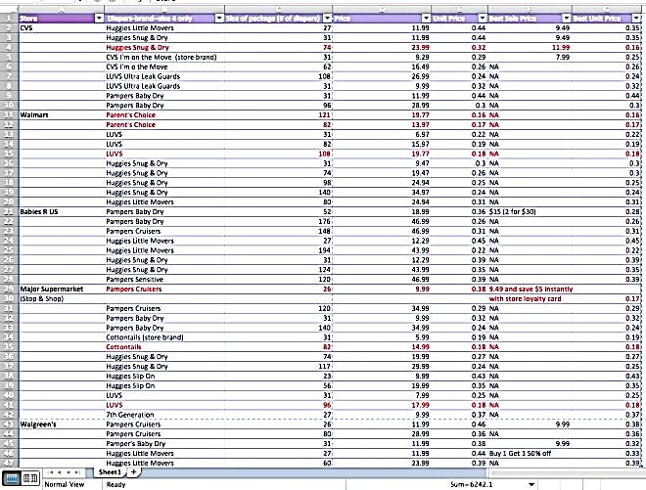
According to my diaper price book, Pampers Baby Dry are the least expensive if I buy the 140-count box (or higher) at Stop & Shop, weighing in at just 24 cents per diaper. That unit price beat Walmart’s Baby Dry price (25 cents per diaper) because at Walmart, Pampers Baby Dry were only available in the 96 count box. Whoa! I would have never predicted that Stop & Shop could ever beat Walmart’s price, but in this instance, it did. And I could have earned points for discounts at the gas station by using my Stop & Shop loyalty card too. Stop & Shop doesn’t have a baby club, but if it did, I’d be sure to join.
I also determined from my price book that a unit price of 24 cents per Pampers Baby Dry diaper is the price to beat at any retailer in my area. So if I can find Baby Drys at that price in my travels, I’m going to snap them up—and only try to buy them at 24 cents per diaper or less. That’s the kind of insight a price book gives you. Here’s what else my price book revealed:
Luvs diapers, which are manufactured by Pampers, are a good deal
If you buy them in large packages (96 count or higher), you can get them for 18 cents per diaper, which is a decent price for disposable diapers.
Bonus:
Like CVS brand diapers, Luvs comes with a money back guarantee. If you’re not satisfied with the leakage performance of Luvs, the company will refund your moola. Just send your original receipt, the UPC from the diaper package, and one unused Luvs Diaper within 60 days of purchase to Luvs Money Back Guarantee, Dept AR, PO Box 1108, Grand Rapids, MN 55745-1108. You’ll get a refund equivalent to the cost of one bag of diapers, plus $1 for postage.
It pays to go big
Smaller packages of name-brand diapers (such as 52 count Pampers Baby Dry) that are on sale (at 28 cents per diaper) still cost more than larger packages (176 count) of the same brand that aren’t on sale (26 cents per diaper). Overall, larger diaper packages of diapers that aren’t on sale trump the sale prices on smaller-size package diapers of the same brand, so buy big unless, of course, you’re trying the diaper out for the first time.
Walmart offers great prices
When you’re diaper compare-son shopping, it’s ideal to compare apples to apples. But try finding a 74-count box of Huggies Snug & Dry, for example, in eight different stores. I did manage to find them in three retailers in my area--CVS, Walmart and Stop & Shop. The winner? Walmart. At 26 cents per diaper (74 count box), Walmart beat Stop & Shop’s price per diaper by a penny for the same-size package. At CVS, each Huggies Snug & Dry (74 count) package cost 6 cents more (32 cents per diaper) than the same size of Huggies Snug & Dry at Walmart.
From my price book, I ultimately determined that in my neck of the woods, I can find the cheapest name-brand diapers at Walmart and Target if I buy giant packages (140 count or more). That’s likely to be true where you live as well.
Overall, tracking diaper unit prices can help you determine the rock-bottom price on your favorite diapers, which signals when it’s time to stock up and cash in your coupons (if you’re buying name brands).
Coupons can change up the landscape even more. In general, you’ll always want to buy the largest size diaper package you can find unless you’re trying out a diaper brand or type for the first time. Given that, here are the cheapest diaper price scenarios (from cheapest to most expensive), in this order:
- Name brand on sale with a coupon.

- Store brand on sale.

- Store brand at regular price.

- Name brand at regular price.

The trick is to know the rock-bottom unit price for your diapers of choice (which may be more than one brand), then to buy diapers when and where you can find that unit price for your stockpile.
Psst! Check out Wal-Mart’s ad-matching policy:
Wal-Mart has a generous ad-matching policy, so if your favorite brand and style of brand-name diapers go on sale at your local supermarket or another retailer for less than what they’re selling for at Wal-Mart, Wal-Mart will give you the supermarket’s sale price. Wal-Mart will match the sales price at the register. Just alert the cashier before he or she scans the diapers you’re buying. You don’t even need to have a competitor’s sales circular with you to prove that the diapers are on sale elsewhere cheaper. Wal-Mart’s ad-matching policy applies to everything, not just diapers, of course.
#13 Compare online diaper prices at:
www.mysupermarket.com. If you’re a frequent online diaper shopper, there’s no need to keep a price book for online diaper prices. Instead, www.mysupermarket.com does it for you. The site lets you easily compare and find the best prices online for diapers, including store brands, across eight online stores, including Amazon, Walmart, Costco, Target, Walgreens, Diapers.com, Soap.com and Drugstore.com. As a mysupermarket.com shopper, you can create lists, share product selections, view the pricing history of a product (when it was lowest and highest, compared to where it’s at now), and receive alerts for price changes on diapers and a variety of household items.
I did an online diaper run on mysupermarket.com for my fave diaper (Pampers Cruisers, size 4) by putting “Pampers Cruisers size 4” in the search box and then sorting by unit price. It was easy to spot the best diaper deal, which happened to be 30 cents for Cruisers in the 152 count package from Walmart.com on the day I was shopping. Shipping happened to be free that day too, which is always a plus.
#14 Ditch your virtual cart
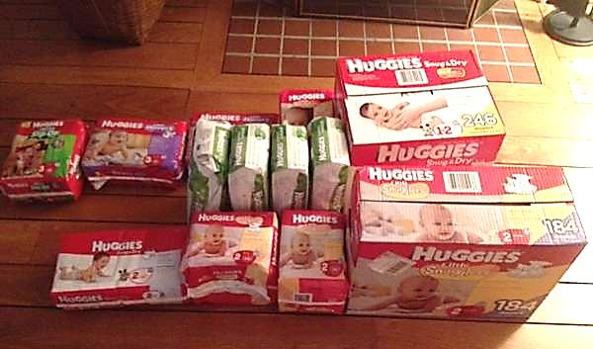
No matter where you’re online diaper shopping, try leaving your diapers in your shopping cart for a day or so—yes, just ditch your cart right in the virtual aisle.
When I abandoned my cart at Mysupermarket.com with my diaper order, for example, I received an unexpected e-mail after signing up on the site. It indicated that $20 will be deposited into my PayPal account if I spent $75 on my first order. Since I was about to plunker down $45.88 anyway for a 152 count package of Pampers anyway, I added to my order so I could take advantage of the deal and get a $20 rebate. Retailers can tell when your shopping cart is loaded but idle. (Cue eerie music.) Walking away from your cart for a while can buy you time to get an even bigger discount.
#15 Scan Craig’s List and eBay for disposable diaper deals
As you may know, some babies graduate from diapers before Mom’s stockpile is gone. Listing them on Craig’s List or eBay for cheap is one way to get rid of them—and for you to stock up on quality, economical disposables. When I scouted on Craig’s List for disposable diapers, I found one local mom who was selling 804 Huggies diapers in various sizes in unopened packages for $100, or 8 cents per diaper—and that was before negotiating. That’s her for-sale stash (pictured). As you probably know by now, eight cents per diaper for any diaper—name brand or store brand--is deep discount territory. Overall, Craig’s List and eBay can be legitimate ways to build your diaper stash at tremendous savings.
#16 Watch for diapers at your local Goodwill
The Goodwill doesn’t take certain baby item donations. But their guidelines don’t preclude disposable diapers. So if you’re a Goodwill regular, keep your eyes peeled for dirt-cheap disposable diapers, preferably in unopened packages. While I was on my diaper price book hunt, I checked my local Goodwill to see if they had any disposable diapers for sale. The store was diaperless that day. Cloth diapers, which I focus on in the next chapter, were absent as well. If you’re a Goodwill regular, be on the lookout for disposable (or cloth) diapers. But don’t make a special trip. It’s hit or miss.

#17 Buy diapers with discounted gift cards
Online gift card exchanges make it easy to buy gift cards from other consumers—at a discount of 5 to 30 percent. On Giftcardgranny.com, for example, which vets gift card buyers and resellers, I purchased a $20 Target gift card for $17.80, a 7 percent discount. Using a discounted gift card plus a coupon code or coupon on your diaper purchases is a great way to super stack your savings.
#18 Stick with conventional disposable diapers
Disposable diapers with special features, such as those that are biodegradable, hypoallergenic or “natural,” are more expensive than name-brand disposable diapers that aren’t on sale. You’ll pay around 38 to 74 cents per niche diaper, which is the highest end of the disposable diaper cost spectrum. If you’re going to use disposables, the decision to use an eco-friendly or hypoallergenic disposable is a personal one. If saving money is your main concern, though, you’re better off sticking with a basic disposable, buying the store or name brand, and trying to buy at a discount. If you’re more concerned about the environment, you can still use the strategies I’ve outlined in this chapter to buy biodegradable, hypoallergenic or “natural” diapers at the lowest price available.

Mix and Match
As you can see, there are multiple ways to save on disposable diapers. Feel free to combine these cost-cutting strategies to maximize your discounts. You could, for example, buy the largest size box of diapers on Diapers.com with a coupon code or two and shop through the Ebates.com portal. Or how about buying store-name diapers on sale at Target.com using a discounted Target gift card? Let’s play that savings game. Here’s how that deal would fly, using a real-world example, which I found online at press time.
Let’s say I’m in the market for size 4 disposables and I like Target’s Up and Up brand. I shop at Target.com and I see the 156 count box is on sale for $24.99 (regularly $28.99), a savings of $4. There’s a promotion: If I buy two boxes, I receive a $5 gift card. I decide to go for it. So far, my savings equals $13 ($4 per box, plus $5). Instead of paying $57.98, I’m at $44.98 for 312 diapers, or 14 cents per diaper.
That’s a great unit price, but I know I can do better. To pay, I shop through Ebates.com and receive a rebate of 2.5% on the price of the diapers, not including the rebate (which amounts to $1.24) and use a $50 Target gift card that I bought through Giftcardgranny.com for $48.75 (a $1.55 savings). Total cost: $42.19, or 13 cents per diaper, which I know from my diaper price book is a rock-bottom price for disposables. But I also decide to sign up for Target’s Subscription program (Target’s version of Amazon Prime) to save another 5% (off the sale price of $44.98, which equals $2.24) and get free shipping. I ultimately pay $39.95, or 12 cents per diaper, a total savings of $18.03. My original cost, without a sale or any of these shenanigans, would have been 18 cents per diaper, which is what store-brand diapers typically go for. That’s still a good price for disposables. But all told, saving $18.03 feels better. Hey, it all adds up.
Buying disposable diapers at a discount takes thought and effort. To save around $18, I bought store brand diapers on sale with a discounted Target gift card, took advantage of a special promotion, shopped at Target.com through the Ebates.com portal and benefitted from the discounts avail-able through Target’s subscription program. But I think it’s worth the work—and besides, the finagling is fun, especially when you see how much you can save on your receipt or at checkout. In today’s deal culture, why not do everything you can to get disposable diapers for your baby at the best price?

Chapter Three

Join the Cloth Diaper Revolution

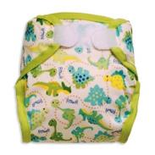
T
o save a bundle on diapers, you’ve got another option besides buying name-brand or store-brand disposable diapers at a discount: Cloth, a.k.a. “reusable” diapers.
When I started writing about baby products for Consumer Reports in 2003, cloth diapers were of a bygone era. Then, the green movement hit, followed by the recession. Now, cloth/reusable diapers are back and represent a growing trend in diapering. Costco and Target.com now sell reusable diapers, which is a retailing milestone. It signals that cloth diapers have once again gone mainstream. Worldwide, it’s estimated that 35 percent of parents are cloth diaperers, with 5 percent (and growing) residing in the U.S.
Among their benefits, reusable diapers are “green” because there’s no plastic to decompose in landfills. They can be a sizeable cost cutter too. If you’ll spend $2,500 on name-brand disposables or $2,000 on the store brand disposables from birth to potty training, consider: A moderately-priced stash of reusable diapers that can last you from infancy through potty training costs around $500. That’s up to an 80 percent savings. And that’s if you use pocket diapers, a popular option that consists of a moisture-resistant cover that includes a pocket into which you stuff an absorbent insert. (More on pocket diapers in a minute.) Although pocket diapers aren’t the cheapest cloth diapers out there, they’re one of the easiest cloth diapers to use and master.
If you really want or need to get economical, you can use old-fashioned prefolds, rectangular cloth diapers with absorbent padding in the middle that are secured with a new-fashioned rubber fasteners, such as a Snappi or Boingo, instead of pins and a waterproof cover. By using prefolds with just enough diaper covers to get by, you can do an entire infancy-to-potty-training diaper barebones stash for just $100.
Another way to save: Start out with preowned cloth diapers. For her two children, Heather McNamara, the executive director of the Real Diaper Association in San Diego, which promotes the use of cloth diapers, bought all of her reusable diapers used through Diaperswappers.com, an online marketplace to buy, sell and trade cloth diapers. By starting with used reusable pocket diapers, an entire pocket diaper stash will likely only cost you $300, a $200 savings compared to starting out with new pocket diapers.
Many diaper sites, such as www.clothdiapertrader.com as well as eBay and Craig’s List offer secondhand shopper-tunities. A caveat: Because the quality of used cloth diapers can vary, it’s a tad risky to buy used diapers directly from other parents. The “like new” cloth diapers you think you’re buying could be thread-bare, in your opinion. You’re not exactly stuck in that situation though. You could always try to resell them. Still, to take the guesswork out of buying used reusable diapers, some cloth diaper retailers, such as www.cottonbabies.com, have buy-back programs (theirs is called “Growing Up in Cloth”) in which cloth-diapering families can sell their used cloth diapers back to the retailer for online store credit. Cottonbabies inspects diapers that are returned for resale. Only cloth diaper brands that are sold on cottombabies.com originally be resold on the site if they pass inspection. Used diapers that don’t make the cut get returned to the customer. If you’re interested in using cloth and reselling them down the road, consider whether the online vendor has a buy-back program.
Whether you spend $100 or $500 on cloth diapers (or up to $700 at the highest end), you’re set. Reusable diaper covers and inserts can last from baby to baby. And when you’re finally done with cloth diapers, you can sell to recoup some of your expenses. Such a deal!

The Cuteness Factor
With disposable diapers, babies aren’t necessarily con-sidered fully dressed if they’re just wearing a diaper. But with reusable diapers, it’s fine if the diaper shows. In fact, cloth diapers are a fashion statement. They’re considered apparel or an accessory. Moms have been known to pair cloth diapers with leg warmers, a T-shirt and a sweater, with the diapers as the baby’s bottom half and call it a day. Who would think that diapers could make an outfit?
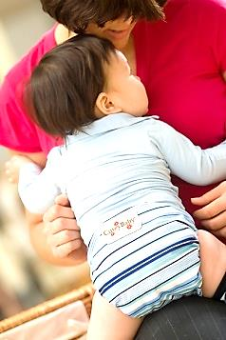
Cloth diapers can be so adorable, in fact, they’re addicting even. Some moms consider them collectibles, like antiques or fine wine. When a new cloth diaper fabric pattern comes out, they make sure their baby is in it. Collecting cloth diapers because you must have the latest pattern and color can increase your cloth diapering costs. So consider yourself warned. Still, if you go a little crazy and buy many more than you need, you can always try to resell the ones you want to retire. The secondhand cloth diaper market is thriving.

What’s Available
Major brands of cloth diapers include Bambino Mio, Bottombumpers, Bum Genius, Bumkins, Charlie Banana, CuteyBaby, Dappi, Econbums, GroVia, Happy Heiny www.happyheiny.com, Kissaluvs, Kushies www.kushies.com, Moraki, Osocozy, Rumparooz, Smart Bottoms, Thirsties and Tidy Tots.
Sweat Equity
The trade-off with cloth diapers and the cost savings is that they’re more labor intensive. Compared to using dispos-ables, you’ll have to wash and change diapers more often and do more laundry. If your baby hasn’t done a number two, which necessitates an immediate diaper change no matter what type of diaper you use, you just can’t go four hours between diaper changes like you can if you had to with disposables. With cloth diapers, you’ll routinely need to change diapers every two hours, to prevent leaks, diaper rash and irritation.
Moms and dads who use cloth diapers consider it a “lifestyle.” And that’s because it affects their daily routine. If you opt for reusable diapers, you’ll need to keep up with the laundry, washing diapers every two to three days, which generally adds up to about two to three extra loads per week. Diaper changes with reusable diapers in general take longer too, an extra two minutes per diaper change.
Still, cloth diapering can be easier than it sounds once you give it a try. “The first week I tried All-in-Ones, I thought, ‘This isn’t that hard. Why aren’t more people doing this?’” says Ada Vaughan, who then launched her own reusable diaper brand, CuteyBaby, as a result of her cloth-diapering experience. (All-in-Ones are a type of cloth diaper; more on those in a minute.)
Many cloth diapering innovations have taken root in recent years, making deciding which cloth diaper to use a challenge. If you’re game to give cloth diapers a try, however, and I certainly would be if I were doing it all over again because of the cost savings and the environmental factor--here’s a rundown of your options and the pros and cons.

Cloth Diaper Choices
Cheap, Cheap But Labor Intensive:
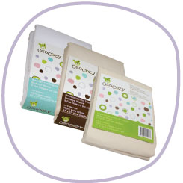
Flats or unfolded diapers are diapers in their simplest form--rectangular cotton fabric that you fold around your baby and secure with old-fashioned pins (ouch!) or another type of fastener, such a Boingo or a Snappi, which is rubber clip that clasps the fabric with a little claw grip with no sharp points (better). Flats date back to the end of World War II, when diaper services, which delivered clean flats to your door step each week, became popular. Diaper services still exist, but since farming out the dirty work adds to the cost, I recommend laundering cloth diapers yourself.
Flats’ close cousin, prefold diapers, are equally as basic except they have extra built-in cotton layers in the center of the diaper for absorbency. Like flats, prefolds are typically cotton and require pinning/ fastening and a waterproof cover, which could be plastic pants or fabric infused with polyurethane laminate (PUL). It’s a soft, pliable and waterproof plastic, to keep cloth diapers from leaking.
Pros: At roughly $2 per diaper, flats and prefolds are the absolute cheapest ways to go in the cloth diapering world. For extra absorbency, consider adding a soaker to the crotch, which is a rectangular or contoured multilayered pad. To save even more money and sun-bleach out stains, flats and prefolds are easy to line dry.
Cons: Flats and prefolds are the most labor intensive of the cloth diaper types. There are at least two pieces to deal with—a diaper and a cover. And there’s nothing in them that can inherently keep diaper rash at bay. It’s just your baby’s bottom against cotton or polyester cloth. That’s also true for all types of cloth diapers. Cloth diapers are low tech.
Price: A full supply of flats or prefolds will run you $100 to $250—and that’s from birth to potty training, a 96 percent savings compared to the cost of premium disposables, including the cost of covers. You may need to spend another $20 or so for replacement diapers as you go along.
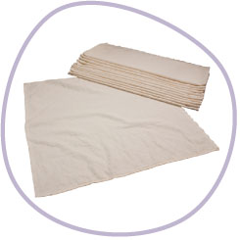
How many to buy
If you want to use flats or prefolds fulltime, get a minimum of three dozen in small (newborn to 15 pounds) and large (15 pounds+). Get 3 to 4 waterproof covers for both sizes too.
That’s the bare minimum. If you can afford it, buy 10 waterproof covers. There’s no elastic around the waist or legs with flats and prefolds, so diaper covers will get dirty often. “If you’re into sewing, you can even make your own prefolds,” says Dennis Frederick, the owner of Osocozy Diapers/www.clothdiaper.com. Here’s one tutorial that outlines the basic steps. Sites such as Wahm Supply also sell complete diaper bundle packs to make 15 diapers, including PUL fabric for diaper covers.
Where to buy flats and prefolds
Bumkins
www.clothdiaper.com
www.econobum.com
www.diapers.com
www.osocozy.com
www.target.com, among other retailers.
To-do tactic
To fold flat diapers, there are two basic methods: the triangle and the origami fold. Visit sites, such as www.osocozy.com for how-to instructions. YouTube offers countless videos that demonstrate these techniques too. If you decide to use flats, fold them ahead so you have a stack ready to go when you are.
Choose prefolds and flats if: Budget is your main concern.
Fitted or contoured cloth diapers are shaped like dispos-ables, with a trimmer crotch area that has extra fabric in the “wet zone” and wide wings that wrap around your baby's waist. They’re secured with Velcro, snaps or pins. They may or may not have elastic at the waist and legs. With fitted/contoured diapers, one-size diapers are available to fit babies 7 to 35 pounds. Contoured diapers are similar to All in One cloth diapers (coming up) except you also need a waterproof cover. The soaker is sewn in.
Pros: There’s nothing to fold. Fitted/contoured diapers don’t require it.
Cons: One-size diapers can be tricky to fit properly. Fitted diapers can seem too big for babies at the start of the weight range and too small for babies at the end of it. Fitted diapers can be made of hemp, which can become scratchy over time. Cotton, another popular fabric for fitted/contour diapers, can shrink.
Price: $10.95 to $13.55 per diaper.
Where to buy contoured/fitted diapers
Amazon.com
TinyTush.com
Diapers.com
KellysCloset.com
Diapers.com and
GreenMountainDiapers.com, among other retailers.
To-do tactics
Pair a fitted diaper with an absorbent, washable fabric soaker insert.
Choose fitted/contoured diapers if: You’re on tight budget.

Moderately-priced and user friendly
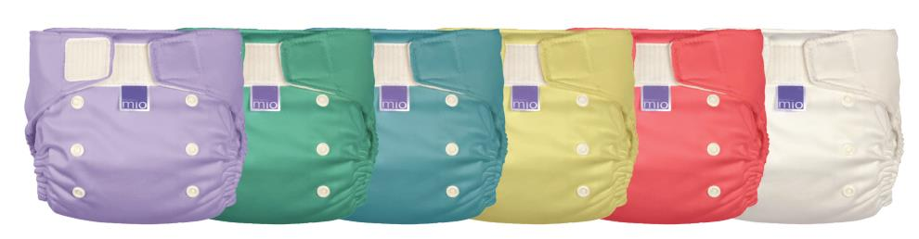
Pocket diapers are a popular reusable diaper style that consists of a moisture-resistant cloth, nylon or polyester cover with a pocket into which you stuff a fabric insert called a “doubler,” “soaker,” or a “liner.” The pocket in the diaper allows you to customize the diaper’s absorbency. You can add more than one insert if you need to, which could even be a folded prefolded diaper. Pocket diapers are one of the easiest cloth diapers to use because they mimic disposables in design. Pocket diapers come in a range of sizes to make the leg sizes smaller and then larger, to grow with your baby. Velcro fasteners or several rows of snaps keep the pocket diaper fitting snugly.
Some pocket diapers come in one size to accommodate children of all sizes, from infants to toddlers. Rows of snaps at the waistband make the diaper larger or smaller. Lots of parents like the sound of using only one size diaper no matter what size their baby. One-size reusable diapers are big sellers in the cloth diapering world. But there’s a big issue when your baby is little. Putting a newborn in a one-size diaper means you’ll have lots of extra fabric to contend with, which, well, looks funny. The truth is, “one-size diapers are best for a bigger baby,” says Gaëlle Wizenberg, owner of Charlie Banana, a collection of baby and children’s products, including cloth diapers, which combines eco-friendliness, quality, and design in one brand. If you’ll be trying pocket diapers from the get-go, start with the extra-small size, she says. Then buy the medium or large as your baby grows, then extra large, if necessary. (Pocket diaper sizes vary per brand.) Although buying three or four sizes of pocket diapers will add to your total cost, they’ll offer a better fit and look better on baby, especially in the beginning, than a one-size pocket diaper will.
Pros: Pocket diapers are relatively easy to use as far as cloth diapers go and the learning curve is low.
Cons: Because you’re stuffing a soaker into a pocket in the shell of the diaper, you’ll have to wash the entire diaper every time. Pocket diapers can take longer to dry in the dryer and on the clothesline flats and prefolds. But because the soaker is washed and dried separately from the diaper cover, pocket diapers don’t take as long to dry as All in One cloth diapers, which I discuss next.
How many to buy: 24 for a full stash.
Price: Expect to spend $500 to $700 on pocket diapers if you use them from start. The average price for one is $24.
Where to buy pocket diapers
Target.com (Target.com sells Charlie Banana, among other brands of reusable diapers)
Amazon.com
ClothDiaper.com
CuteyBaby.com
Diapers.com and Walmart, among other retailers.
To-do tactic: To save time, preload pocket diapers with soakers when you’ve got a few spare moments so you’ve got a stockpile of good-to-go diapers on deck when it’s time to change your baby.
Choose pocket diapers if: You want the ease of a one-piece system.
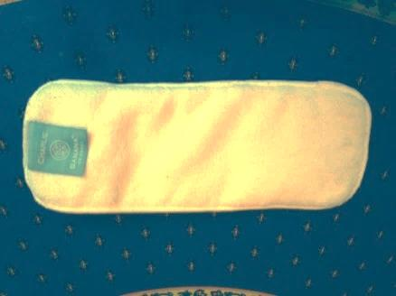
Soaker
All-in-one diapers (AIOs) are similar to contour diapers and pocket diapers except there’s no pocket for an insert/ soaker/liner/ doubler. The diaper and the outer waterproof cover of the diaper are integrated into one piece of fabric so diaper changing is a one-step process. You just throw away the solids and toss the whole thing into the diaper pail/bag for washing later. Many AIO diapers come in two or three sizes: small, medium and large or just infant and toddler.
Pros: Since there’s only one part to deal with, AIOs are super easy to use, even easier than pocket diapers because there’s no pocket to stuff.

Cons: Because they come in one piece, they're also bulky and thick, so they don’t dry quickly after laundering.
Price: Expect to pay around $575 for a stash of 24, which may last you until the next baby. The average price for one is around $24.
Where to buy AIOs:
www.amazon.com
www.cottonbabies.com
www.cuteybaby.com
www.clothdiaper.com
www.diaperjunction.com
www.gdiapers.com
www.nickisdiapers.com
www.osocozy.com and
www.target.com, among other retailers.
To-do tactic
Like pocket diapers, you have to change an entire AIO every time, unless, that is, you add a disposable (biodegradable) liner (it’s like a dryer sheet, only thinner) to collect solids. At changing time, if your baby just did a number two, you just peel the liner from the diaper and flush it with the solids down the toilet. If the diaper doesn’t get dirty, you can keep using it. Some AIOs come with a fabric soaker that snaps onto the crotch of the diaper. These cloth diapers have their own name, “All in 2s.” To change All in 2s, you can just wash the soaker if the rest of the diaper isn’t soiled or wet.
Choose AIOs if: You like the idea of a one-piece system and want diapers that function as close to disposable diapers as possible, apart from the washing.
How many to buy: To avoid washing diapers too frequently, which wears them out faster, you’ll need around 24 AIOs in your stash.

The Daycare Dilemma
The fact your baby attends daycare shouldn’t be a reason not to try reusable/cloth diapers. Because many parents are cost-conscious, “more and more daycares are accepting cloth again,” says Dennis Frederick, owner of www.osocozy.com and www.clothdiaper.com. (Before disposables, cloth diapers in daycare centers were the norm.)
To use cloth diapers in daycare, many daycare facilities will only allow all-in-one diapers, which are the most like disposables, only they never get thrown away. The daycare center may also be governed by state regulations for diapering. In my state, for example, (Connecticut), parents need to provide the daycare center with a place to store their child’s used cloth diapers and any soiled clothing, such as sealed, airtight container like a Ziploc bag. You’ll also need to take soiled cloth diapers and clothes home at the end of the day to wash them. Otherwise, everything else is exactly the same for disposables and reusables as far as diaper changing goes. Still, washing a bag of diapers is more to do when you’ve got a lot on your plate already, such as a full-time job and a new baby. But if you don’t mind, daycare is expensive so saving on diapers by using cloth diapers could make the extra dirty work worth it.
To find a cloth-diaper-friendly daycare in your area, the Real Diaper Association offers a cloth-diaper daycare directory. When I plugged my Zip code into the search box, for example, I found one cloth-diaper-friendly daycare 25 miles from my house—but it wasn’t on the way to work. There may be daycare centers that accept cloth diapers that aren’t listed in this directory. So don’t give up. If your baby will be attending daycare and you want to use cloth diapers fulltime, call the contender licensed providers in your area to check to see if they are cloth-diaper friendly.
If your baby attends a daycare that doesn’t accept cloth diapers, you can always just use cloth diapers at home. Lots of cloth diaperers are “combo moms” or combo dads. Even just using cloth diapers some of the time, such as at night, on the weekend, when you’re traveling with your baby, trying out a new babysitter, or when you’re visiting your relatives, can reduce your disposable diapering costs enough to justify the mix and match approach.

Hybrid Diapers:
Pricey yet still cheaper than using regular disposables Hybrid diapers are a combination of cloth and disposable diapers and one brand—gDiapers—put hybrid diapers on the map. The gDiaper is comprised of 1) a reusable cloth cover called gPants with 2) a disposable, biodegradable insert that functions as the guts of the diaper. The insert is made from cellulose rayon, fluffed wood pulp and super absorber—sodium polyacrylate, nontoxic, water-absorbing polymer. gDiapers’ biodegradable disposable insert fits inside 3) a waterproof pouch that snaps into gPants. gPants come in a variety of colors, with the exception of newborn gPants, which only come in white. They come in sizes newborn, small, medium, large and extra large, but “babies often spend most of their time in mediums,” a gDiapers customer service representative told me. As I mentioned, medium-size cloth diapers are the workhorse.
When you change a gDiaper, you flush the disposable insert down the toilet, compost it, or toss it in the trash, and add a fresh disposable insert to the waterproof pouch that snaps into the gPants. You’ll only need to wash the gPants (diaper covers) when they get dirty, maybe every three days or so.
gDiapers also sells diapers with removable cloth inserts. Since there’s nothing to be thrown away, these diapers are considered all in ones, not hybrids. But if you use them with a flushable liner, you’re back in hybrid territory. In addition to gDiapers, other popular brands of hybrid diapers include GroVia, Flip and Charlie Banana, which offers a 2 in 1 system that can be used with reusable or disposable inserts.
Pros: Hybrid systems aren’t the least expensive cloth diapers available, but they cost less to use than using regular, 100 percent disposable diapers and there’s a biodegradable component for the good of the environment.
Cons: For some hybrid systems, there are multi-components and consequently, a lingo and a learning curve--for using them and, depending on the baby, getting them to fit so that they don’t leak. To get familiarize with gDiapers, which is a good idea before diving in, watch the video on the gDiapers’ Website and read the site’s how-tos. Ditto for GroVia. In other words, there’s homework. Another downside? The main component of gDiapers, the flushable insert, isn’t recommended for septic systems or for people with homes that have plumbing issues. That may hold true for other brands of flushable inserts as well so take heed. If you’re on a tight budget, the cost of the flushable inserts and the cloth inserts can feel burdensome. In general, a hybrid system is more expensive than other regular cloth diapers but not as costly as using disposables. . Using them with washable cloth liner (which aren’t disposable), at least some of the time however, can make hybrids more affordable over the long run.
Price: The gDiaper system has various components that can be purchased together and separately. The gPants themselves cost $17.99 to $21.99 each (for the latest designs). Six packs cost $79.99 to $89.99 (roughly $13 to $15 per diaper). GroVia is similar. Its snap closure shells retails for around $16.95; two reusable cotton pads run $17.95 and a 20-count pack of disposable BioSoakers cost $7.99.
To determine how many gDiapers you need to buy from birth to potty training and how much it would cost if you went with this system, the gDiapers customer service rep I chatted with on gDiapers.com recommended buying the Newborn Starter bundle because “it’s popular with new families.” It includes 80 disposable inserts, the guts of the diaper that gets flushed, composted or trashed ($149.99), a six-pack of Rainbow g’s (cloth covers), small and medium sizes ($89.99 x 2), gPants pouch, 6-pack ($22.99) and a cloth insert two-pack ($59.99). Total: $412.95.
That’s for starters. You’ll have additional expenses along the way, such as additional disposable inserts ($52 for a 4-pack, 128 count each, for sizes M, L or XL). But the costs still don’t add up to more than using regular disposable diapers ($2,500).
Where to buy hybrid diapers
gDiapers.com
Gro-Via.com
Flipdiaper.com
Babiesrus
diapers.com
Target
Amazon
Walmart
Walgreens
Vine.com
You can also buy hybrid diapers used on eBay and Craig’s List.
To-do tactic
If you’ve got questions about hybrid diapers, visit the diaper brand’s Website and call or live chat with a customer service to get answers to your specific questions.
Choose hybrid diapers if: You like the idea of a diaper that’s a cross between a disposable and a reusable diaper; budget is less of a concern than protecting the environment and you’re detailed oriented and organized.

Fit Tip: Stock up on the medium size
The size of cloth diaper you buy can depend on your baby and when you start using reusable diapers. With most types of cloth diapers, babies tend to spend the most time in the medium size. For some babies, such those with long and skinny legs past the infant stage and babies who don’t start wearing cloth diapers until they’re six months old (a common age when many parents discover cloth diapers because they’re tired of paying so much for disposable diapers)—a medium-size cloth diaper may be all they wear. They may be able to stay in a medium until potty training.
Do cloth diapers make daycare centers dirtier?
Germ alert: Fecal matter residue in daycare centers is an issue with any type of diaper (radar: diarrhea). But according to a 1995 study in the American Journal of Public Health, daycare centers that allow cloth diapers should be just as clean as those that don’t. In the study, researchers monitored one infant room and two toddler rooms in four day care centers in Tennessee that used cloth or disposable diapers for the presence of fecal bacteria. After eight weeks, they found that cloth diapers didn’t contaminate the environment with fecal matter anymore than disposable diapers did.

Chapter Four

Product Spotlight: Tidy Tots—the Cloth Diaper Reinvented
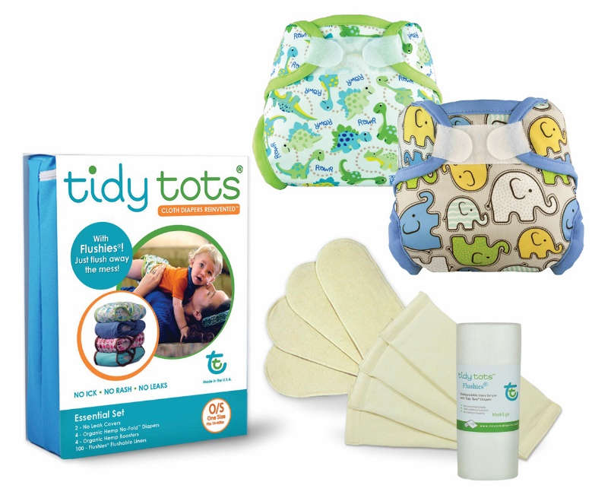
I
f you like the idea of reusable diapers, pocket or all-in-one cloth diapers are a good place to start. They’re easy and not so different from disposables. Among the pocket/AIO crowd are Tidy Tots diapers, which get a chapter all to themselves because I think they’re worth singling out.
Invented by New York State entrepreneur Sandra Beck, Tidy Tots diapers are her version of the ultimate cloth diaper. The back story: After selling a tech company, Beck wanted to start a new venture that “made a big difference in the environment.” Her initial intent was to create an e-commerce Website that vetted the very best environmental products available, with cloth diapers the first product to be sold.
To find the top cloth diapers to sell on her site, Beck “ordered every cloth diaper from around the world that I could get my hands on,” she says, including cloth diapers from China, the United Kingdom, Japan, Australia and every diaper on the market sold in the U.S. at the time. To test the diapers, Beck created focus groups of parent testers who used them on their babies. “I discovered that every one of the diapers had innate problems,” she says, which she describes as: “the ick, the rash and leaks.” Over the next seven years, Beck set out to address those issues. She sewed cloth diaper prototypes and enlisted 100 families to test what she made. “We went back and forth until I perfected Tidy Tots,” Beck says.
The patented Tidy Tots have four parts: 1) A PUL (laminated fabric) cover, 2) a no-fold hemp diaper, which snaps into the cover. Hemp is an absorbent natural fiber. “It’s antimicrobial so it can’t create bacteria,” Beck says. 3) A hemp “booster”--a hemp pad that gets inserted with the no-fold (for heavy wetters who need extra protection), and 4) Flushies, which are biodegradable liners made from cornstarch. “The soothing flushable liner secures to the no-fold diaper with a Velcro strip and the no-fold diaper snaps into the cover on both ends,” Beck says. To get a clearer idea of what’s going
on, watch the video on Tidy Tots Diapers, to see the diaper in action.
Tidy Tots are designed to quarantine the solids. The Flushies make it easy for diaper changers to gather up the mess and flush it down the toilet. They help keep the diaper cover clean too, which means less washing. “The solids are protected. In our last testing, most moms could use the cover four to six times before needing to wash it again,” Beck says. Between washings and after each diaper change, though, it’s a good idea to wipe out the inside of the diaper with a baby wipe.
There’s more: The diaper seams are sealed with PUL trim to prevent leaking. Tidy Tots also have a patented leak-proof gusset, an elastic section by the legs. “It took years to design the gusset and years to perfect the elastic in it,” Beck says. The gusset allows the Tidy Tots diaper cover to be one size without snaps in the front, which are typical of other brands of one-size cloth diapers that can be worn from infancy through potty training. To prevent leaks around the waistband, Tidy Tots have elastic there too, and a special fold. “I’ve never had anyone who has purchased my diapers tell me they’ve had leaks. The way I’ve designed them, it’s almost impossible,” Beck says. Tidy Tots are made in the U.S. Disabled adults are employed to assist in assembling parts of the product. “It’s all about giving back,” Beck says.
Tidy Tots are competitively priced. Each cover (the shell) retails for $19.95. If you’d like to give Tidy Tots a try, Beck suggests trying the Essential Set to see how you like the diapers. For $99.95, it contains two no-leak diaper covers, four No Folds (the organic hemp insert that goes into the cover), four boosters (the organic hemp pad for heavy wetters), and a roll of Flushies (100 disposable liners). If you’re sold on the product or want to list Tidy Tots diapers on your baby registry, get the Great Start set. It contains six diaper covers, 12 No Fold diapers, eight boosters and a roll of Flushies for $269.95.
Beck frequently runs specials on her Website, Tidy Tots Diapers, such as 20 percent off or a free diaper cover if you buy a Tidy Tots set. To receive specials right in your inbox, sign up on her Website and create an account. Beck offers a 60-day money-back guarantee on Tidy Tots. So far though, “no diapers have been returned,” she says.
Fit tip: Mind the gap. No matter which type of cloth diaper you try, fit is important to avoid leaks. The fit test: Lift up your baby’s legs after you’ve put on a new diaper. You’ve got a good fit when the diaper is snug against your baby’s legs. You shouldn’t be able to see any gaps.

Chapter Five

Saving on Cloth and Hybrid Diapers
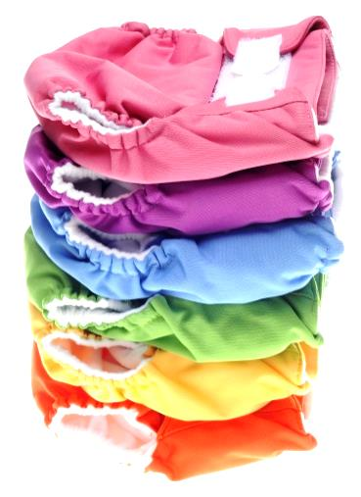
I
t’s no question that using cloth/reusable diapers can be a significant money saver. Still, the upfront cost of cloth diapers—likely hundreds of dollars for an entire system--can be prohibitive. It’s also risky if you haven’t tried the diapers before. Nobody wants to invest in cloth/reusable diapers that end up being a bad fit for (resulting in chronic leaks), irritating to your baby’s skin or unsatisfactory for other reasons.
If you’re on a tight, tight budget or you just want to spend as little as possible, consider an ultra-economical system, such as flats or prefolds. If you’ve got a little more spending power or want to make a fashion statement, start with all in ones or pocket diapers. Disposable liners can make any cloth diaper easier to use, so put those on your shopping list too.
Cloth diapers are like blue jeans. You can have several different types and brands, but one style that fits your baby the best and works every time. They’re the ones you’ll reach for again and again. As a beginner, however, you’re in experiment mode so expect trial and error. Just having that insight can help you shop more strategically. Don’t invest in a cloth diaper system until you figure out which one works best for your baby. The following suggestions can help you find that go-to cloth diaper while minimizing your expense. Again, feel free to combine savings strategies.
Start small
Many cloth diaper companies offer a trial pack, which may include one cover and several inserts or a starter set, which typically comes with up to six diaper covers. For a small investment—$5 to $40 or so--a trial pack or starter set can give you an idea of how the diaper performs over several days and what it will be like to use it fulltime, if you decide to buy more. Here are examples of starter sets I found at press time:
GroVia’s First Steps package includes one hybrid diaper cover, two organic cotton soaker pads and 20 BioSoaker disposable liners. It retails for $39.
Econobum sells a one-size cloth diaper trial pack at Walmart.com for $16.96. It includes one one-size cover and three one-size prefolds (the absorbent innards).
Sign up for a trial program
Trial programs are more expensive than trial packs. They allow you to try a sampling of cloth diaper types and brands (you choose the diapers to try or they choose, depending on the retailer) for three to four weeks for less than $100. When the trial period ends, you mail back all tester diapers and receive store credit. The returned diapers can be washed and stained.
In fact, one particularly helpful diaper trial program is available at Diaper Junction. The diaper site offers a “30 Day Test Drive” program that allows you to make your own trial pack from leading cloth diaper brands, such as Blueberry, bumGenius, FuzziBunz, GroVia, Rumparooz and Thirsties. You can choose the number and brands you want to buy, including one of each. Your baby can wear them and you can wash them all you want. If you’re not 100 percent satisfied, you can return the diapers within 30 days of receipt for a full refund. You’ll find a list of cloth diaper trial programs at Thirsties Baby. Maybe your local baby boutique offers a similar trial program too.
Buy cloth diapers with a money back guarantee
Many cloth diaper companies that sell unused diapers offer a 30-day or 60-day money back guarantee. The clock usually starts ticking after purchase, so keep your receipt and don’t buy cloth diapers months before your due date. Tidy Tots is an exception. It allows a return 60 days from the day of a baby’s birth. Guarantees can give you the freedom to play the field risk-free. It’s nice to know that if you don’t like the cloth diapers you’ve been using, you can return them for a refund.
Buy discontinued colors/styles
Cloth diapers are a style statement and just like last season’s fashion trends, cloth diaper prints go in and out of style. When they’re no longer big sellers or the manufacturer just wants to refresh its inventory, certain cloth diaper prints get retired and go on sale. You’ll typically find discounted cloth diapers in the online sale section of your favorite cloth diaper manufacturer.
Cottonbabies.com and Kellyscloset.com, for example, offer clearance/close-out prices son select cloth diapers in the sale section of their Websites. At press time Kellyscloset.com was giving its customers one free one-size diaper (worth at least $17) with an order of $89 or more (limit one per order and three uses per customer). Kelly’s Closet chooses the brand of one-size diaper you’ll receive.
You’ll also find discounted cloth diapers at flash sale sites, such as BabySteals.com. BabiesRUs.com also offers great diapers deals on its Website Clearance section on cloth diaper prints that may be discontinued. Babies “R” Us also provides 40% online exclusive discounts on all things baby and printable coupons that offer discounts as high as 15 percent off any regularly priced item.
Buy secondhand from the start
With so many retailed buy-back programs available that vet used diapers, it’s never been easier to buy quality used diapers. You can also try your luck on Craig’s List, mom two mom sales, Amazon, Facebook groups (search cloth diaper b/s/t, which stands for buy/sell/trade). Facebook groups are also available that are dedicated to selling a particular brand of cloth diaper.
Or try a specialty site such as clothdiapertrader.com. The preowned option is a big money saver. If a full set of pocket diapers costs $500, you can usually get them used for around $300. And, as I mentioned, that may be all you ever spend on diapers. Still, when buying secondhand, don’t do a deep dive from the beginning. Start with one or two of whatever type/style of cloth diaper you’re interested in trying. You can always buy more of the style secondhand or new once you know you like them.
To save the most money in the secondhand market, buy stained diapers. Yep. Stained. Used cloth diapers advertised as stained typically cost a lot less than diapers that claim to be stain free. Unless the stains are caused by diaper rash cream, which creates a water-repellant layer, stains can be bleached out by the sun. Ask the seller is she used diaper rash cream. Stains may sound gross but they’re usually no big deal.
When you bring secondhand cloth diapers home, you’ll want to wash them anyway unless they’re never been used and they’re in their original packaging. Soak them in hot water with a small amount of bleach, such as a capful if you’re soaking in the sink or a quarter cup if you’re soaking a batch in the bathtub. After a good cleaning and a few days of rays, the stains should be gone. Unless you’re buying from a reputable used cloth diaper retailer who vets their inventory, caveat emptor. Know the acronyms:
- LN—Like new; the diaper should be virtually akin to a new diaper, sans the packaging. The diaper should include all inserts. The diaper should be fluffy and bright, with no pilling or fading.
- EUC—Excellent used condition; the diaper is nearly new but it may have been tried on or washed a few times.
- GUC—Good used condition; the diaper is still up for the job but it may have minor staining, pilling or snags. The Velcro closure may not be so sticky because of lint or fuzz.
- UC—Used condition; the diaper may be stained and dingy and Velcro tabs that aren’t the stickiest, but still workable.
- MMAO—Make me an offer.
Ask sellers why they’ve classified their condition as “GUC,” for example. Honest sellers should be able to describe their diapers in detail. They post photos of the inside and the outside of the diaper too. But just in case, be sure to pay from a secure Website, such as PayPal, if possible. With PayPal, you’ll also have recourse in case there’s a problem. PayPal’s buyer protection policy specifies that if the item you’ve purchased online from eBay or otherwise doesn’t arrive or match the seller’s description, they’ll look into it. If it’s discovered that something is wrong or missing, PayPal will reimburse you for the full purchase price of the item plus shipping costs. Keep in mind, however, that secondhand diapers are voided of all manufacturers’ warranties.
Shop at CostCo
CostCo offers special limited-time sales on cloth diaper brands so consider joining CostCo if you’re not already a member. “The best deal you’re ever going to find on CuteyBaby is at CostCo,” says CuteyBaby’s Ada Vaughan. But Costco’s deep-discount cloth diaper deals don’t usually last long, so snap them up if you find one.
Contact the manufacturer for a coupon code
Many cloth diapers sold in the U.S. are the product of small companies that have the flexibility to offer coupon codes to consumers who e-mail them through their company Website—and ask. “We’ve given coupon codes to CostCo members who e-mailed us, saying they missed our last sale or bought one of our diapers and want another,” Vaughan says.
Buy cloth diapers with snaps
Psst! They last longer. Velcro fasteners wear out faster. And babies can get the hang of undoing them.
Buy seconds
“Seconds” doesn’t mean second hand, but rather second quality, but they’re still usable. Cloth diaper seconds are new diapers with minor factory imperfections such as uneven stitching, slight fabric flaws, snap misalignment or other minor snap issues, which is why they’re sold at a discount. They’re non-refundable and not covered by the manufacturer’s warranty. The flaws typically aren’t deal breakers though, and could result in a sizeable savings—as much as 50 percent.
Stock up on holidays
Any holiday is a great excuse for a sale so watch for cloth diaper price reductions on Black Friday, Cyber Monday, Valentine’s Day, St. Patrick’s Day, Earth Day, Mother’s Day, Memorial Day, Father’s Day, Labor Day, Columbus Day, and so forth. And, in general, November and December is the season for baby gear deals. That’s when retailers are trying to clear the shelves of their inventory to make room for next year’s merchandise.
Those are just a few of the ways you can save even more on cloth diapers than just simply using them instead of disposable diapers. For more savings strategies, flip back to Chapter 3. Many of the tactics for saving money on disposable diapers outlined there will work to reduce the cost of cloth diapers too. For example, if you buy cloth diapers online at Babiesrus.com, be sure to start at a cash-back portal, such as Ebates.com. At press time, you could earn 2 percent back on all Babiesrus.com purchases. And don’t forget to stack your savings by combining a sale with a coupon or coupon code for cloth diapers and wipes whenever you can.

Chapter Six

Caring for Cloth Diapers and Preserving Your Investment
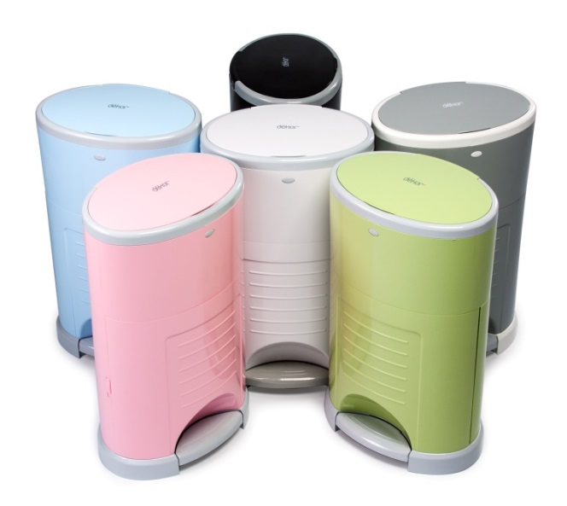
I
f you decide to try cloth diapers, doing the laundry regularly will become a top priority. As you know, your labor is the trade-off for saving maximum moola on diapers. You could use a diaper service, which launders diapers for you, but your diaper costs will rival the cost of using disposable diapers. If being green trumps saving the green stuff, however, then using a diaper service makes sense. You’re not saving money, but you’re not contributing to landfill waste either. If you’re interested in hiring a diaper service, The Real Diaper Service has a National Diaper Service Directory.
Since this book focuses on cutting diapering costs, this chapter will discuss the doing the dirty work yourself, which can save you in more ways than one. By laundering cloth diapers properly, they’ll not only get cleaner, they’ll last longer.
Clean Up Your Cloth Diaper Act
Many cloth diapers come with specific care instructions, which are typically tailored for the diaper’s fabric. If the cloth diaper company has a Website, you can usually find their laundering instructions there as well. I suggest following those instructions exactly since manufacturers have typically tested and vetted the best laundering methods for their diaper’s fabric. To give you an idea, here’s the basic drill for Charlie Banana’s one size pocket diaper, for example: “Knock solids into the toilet, rinse any residue and store in a dry or water pail.” (Note: A water pail, which is filled with water for cloth diapers to soak until washing, was once the norm but don’t use it. A water pail is a drowning hazard and germ magnet.) “Place in washing machine and select cold or warm wash to maximum of 40 degrees C/104 degrees F. Use any eco-friendly detergent, only half of the recom-mended amount is needed. Do not use fabric softener or bleach. Tumble dry LOW or hang to dry. Do not iron. Do not use cream or ointment, unless you are using the diaper insert. (As you may know, it creates a water-repellant barrier.) If using a disposable insert, knock off solid into toilet and place insert into the garbage.” Sounds easy enough, right? It can be once you get the hang of it.
The Real Diaper Association also offers basic washing instructions that cover any type of reusable diaper. Your goal is to produce laundered diapers that don’t smell. If they do, they’re not clean. Here are general laundering instructions that I’ve compiled myself for any type of cloth diaper from several sources.
Flush all solids down the toilet, including a flushable disposable liner, if you’re using one.
Diaper pail detail
Place the diaper and the soiled cloth fabric soaker/ liner/insert (if you’re using one), into a dry diaper pail, super dry bag, a.k.a. a “wet” bag, or a regular garbage can with a lid. A super dry or wet bag is made from PUL, the same leak-proof material of which pocket and other types of modern cloth diapers are made. It’s just in bag form. Use a dry pail and keep it in the bathroom. Or, use a super dry or wet bag and hang it on the back of the bathroom door. You can also use a wet bag as a diaper pail liner. Or, forget the diaper pail bag and just use a bare plastic garbage can with a lid. “I just threw diapers directly inside a plastic garbage pail, and then carried the pail to the washer when it was time. As long as you’re washing diapers every two to three days, your pail won’t smell,” Heather McNamara says. Ada Vaughan of CuteyBaby took a different tact: She put two lidded trash cans in the nursery, one for trash and one for diapers and emptied both every night. “I was an everyday washer because it just seemed easier to me. Daily diaper washing was part of my routine,” Vaughan says.
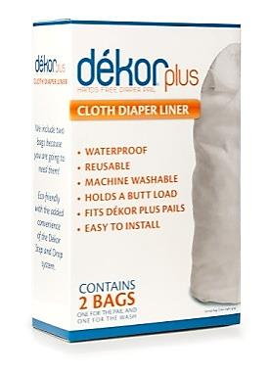
You can also use as a conventional diaper disposal system, such as the Diaper Dekor (diaperdekor.com). Its cloth diaper liner (about $25) fits its Diaper Dekor diaper pail.
One advantage to using a diaper disposal product like the Diaper Décor that it has a lid that locks, which is one less thing to worry about when your baby starts to crawl. Another plus is that the Diaper Dekor’s center insert pops out. It’s designed so you can use it as a regular garbage can when you’re done with diaper duty. It’s sleek and stylish too. Baby products that multitask = savings.
Wash cloth diapers at least two or three times a week, though it’s fine to do a load daily if you prefer. Plan your laundry sessions so that you’re washing 12 to 24 diapers at a time. It’s best to have enough diapers so that you’re not washing the same diapers over and over. Repetitive washing wears diapers out faster. “They might not last until the next baby,” says Dennis Frederick of Osocozy.com.
Tweak your washing machine
On laundry day, the Real Diaper Association recommends machine rinsing the diapers in warm water, then washing them in hot water followed by two warm rinses at the end. There’s always a rinse at the end of a wash cycle, so that just means setting your washing machine to rinse a second time. If that sounds too complicated, just focus on washing your diapers in hot water. “Cloth diapers serve as germ incubators,” says Kelly Reynolds, Ph.D., associate professor at the College of Public Health at the University of Arizona in Tucson. You need hot water to really kill fecal germs. The bad bugs from poop in cloth diapers can last for weeks in the environment and potentially cause illness, such as diarrhea, if they get transmitted to you, your baby or other family members. If you have an energy-efficient washing machine, set it to the maximum load size. You’ll need as much water as possible to get cloth diapers clean. Water plays a major role in the cleaning in general. You need plenty of water to carry away the bad stuff, like poop and germs. If you can’t be bothered with washing your baby’s diapers separately, go ahead and combine your baby’s diapers with the rest of your family’s wash, such as towels that you will be washing in a machine in hot water.
Get picky about detergent
The detergent you use to wash cloth diapers should be free of fragrance, color, optical brighteners and fabric softeners. These laundry detergent additives can cling to fabric fibers, leaving a residue to which fecal and urine molecules can bind. In other words, cloth diapers can clog up and become less absorbent over time and give off an ammonia smell. Likewise, poopy diapers that aren’t properly laundered can make the freshest of babies smell like “a barn yard” and the “bottom of a hamster cage,” as one mom put it. All told, when you take cloth diapers out of the dryer, they should be odor free and just smell, well, fresh.
Buying a detergent designed for cloth diapers can prevent the odor/residue problem. Dennis Frederick of Osocozy, who has been in the cloth diaper business since 1991, recommends Charlie Soap or Rockin’ Green. Both brands have hard water and soft water formulations. Your water conditions should dictate which soap you buy. Rockin Green is made with biodegradable plant-based and free of petroleum, parabens, phthalates, phenols, phosphates, optical brighteners, artificial fragrances, among other ingredients. One bag of Rockin’ Green laundry detergent, which is enough to do 90 loads of laundry, retails for $13.95 to $15.95 at rockingreensoap.com. That’s only about 17 cents per wash. Charlie’s Soap contains natural mineral and biodegradable ingredients and doesn’t use baking soda, zeolites, fragrances, bleach, anti-foaming agents, essential oils, thickening agents, or enzymes. One medium load jar of Charlie’s Soap costs roughly $17 or 17 cents per load.
Kate Cross, a Tidy Tots diaper cloth diaper tester, says she’s found a mainstream laundry detergent that works just as well as Rockin’ Green: All Free & Clear. It retails for around $14.50 for 50 ounces (32 loads of laundry or 45 cents per wash), but if you buy it on sale, you’ll pay a lot less. (All Free & Clear goes on sale often.) Cross has also tried Tide Free, but found that it left a residue on her son’s Tidy Tots diapers. What about Dreft, the grandmother of baby laundry detergents, “formulated to be gentle on a baby’s skin and not so gentle on stains?” Dreft contains brighteners, so it’s not the best option for cloth diaper users.
Unless you have hard water at your house, use less detergent than you think you need to reduce the chances of any detergent residue. If you have hard water, though, the Real Diaper Association recommends using more detergent to compensate for the water’s excessive dissolved mineral content.

Keep tabs on fasteners
If your baby’s’ cloth diapers have Velcro tabs, fold them in before tossing them in the washer. Otherwise, fuzz from the laundry can get stuck in Velcro tabs and quickly render them useless.
Be careful with covers
If you’re using fitted or prefold diapers, hand wash dirty waterproof covers in the sink with dish soap or liquid detergent. Hand washing helps them last longer because there’s less wear and tear on the fabric (plastic). High heat from the dryer can cause excessive wear so be sure to air dry them.
Dry at the lowest setting
To preserve the life of cloth diapers (excluding plastic covers), dry them on the clothes line or in the dryer at the lowest setting. Do the same for fabric soakers. Keep in mind, though, that fecal germs love dryers at low settings because they can survive a low-heat dry cycle. That’s another argument for washing your diapers in hot water. If you don’t, some fecal germs may linger and survive the dryer cycle. More details: Don’t use dryer sheets. They contain additives that can build up on diapers, making them less absorbent and smelly. And besides, cloth diapers and soakers are soft enough without them.
If you choose to line-dry your cloth diapers, you’ll save on your electric bill and any stains will naturally disappear. “The sun bleaches out stains so amazingly, in a way you can’t do in a dryer,” McNamara says. Many busy cloth-diapering parents line dry on the weekends just to get the stains out. Bleach isn’t recommended for laminated fabrics, so don’t use it in your cloth diaper load. But it’s fine to use on fabric soakers. “If you have a stinky set of soakers, a capful of bleach isn’t going to hurt anything,” Vaughan says.

Chapter Seven

Diapers for Rock-bottom Budgets
I
n this book, I outline numerous ways to save money on disposable and cloth diapers. But if even those tactics don’t make sense for your budget or if you just like the idea of getting as many free diapers as possible to supplement your stash, this chapter is for you. Free diapers are available. Here are just some of your options to obtain them.
Diaper Banks. If you’re on the tightest of budgets, diaper banks are available across the U.S. that can provide you with free diapers and cloth diapers through the National Diaper Bank Network (NDBN).
As a founding sponsor, Huggies donates 20 million diapers annually to the NDBN. One out of three families in America struggle to buy diapers because, unlike infant formula, diapers aren't covered by the Special Supplemental Nutrition Program for Women, Infants, and Children (WIC) or any state or federal subsidy program. "As a social worker, I saw firsthand how people were leaving their babies in diapers all day, emptying out the solids and putting the diaper back on their child or trying to wash and dry disposable diapers," says Joanne Goldblum, the executive director of the National Diaper Bank Network in New Haven, Connecticut, which is dedicated to ensuring that every baby in the U.S. can be clean, dry and healthy. "They did things that were not in the best interest of the health and comfort of their child because they had to."
If you're struggling to keep your baby in disposable or cloth diapers yourself or you know someone who is, visit the National Diaper Bank Network to find a local diaper bank in your area. "Many people are reaching out to diaper banks, saying they never thought they would be in a position of asking someone for help to meet the basic needs of their child," says Goldblum. The banks are there to help. There are 137 diaper banks in 17 states across the U.S., some with a choice of cloth diapers for parents who can and want to use them in addition to disposables. The largest diaper bank, in North Haven, CT, gives out nearly 2 million diapers per year.
If diapering your baby isn't a problem or you’ve come across a good sale or employ strategies in this book to cut diaper costs and you want to share the bounty—either diapers or your savings--consider helping a local diaper bank stock up on supplies. "If you have are able to provide for yourself and have something extra, we would certainly appreciate a donation," Goldblum says. The NDBN also features tools on its Website that can help you spearhead your own diaper drive, to collect diapers for the diaper bank in your area.
Freebie Websites
The Freecycle Network (Freecycle.org) is a place to get what you don’t have, such as diapers, and give what you don’t need, such as stuff from your baby shower that you don’t anticipate using. To find a Freecycle group near you, log onto Freecycle.org and complete the signup form to create your free account. You’ll need to join to view the posts. Then, find your community by entering your city and state into the search box on freecycle.org or by clicking on “Browse Groups.” Post your diaper needs under the “Wanteds” category and see what happens.
Listia.com is another free marketplace to frequent for free diapers. It’s similar to the Freecycle Network; it’s a place for consumers to give away things they no longer use and get new things for free. Listia uses a “credits” system. You earn credits when you list and sell your stuff for free and other ways, such as by simply signing up for an account. You can spend your credits by “buying” items other members list. You can even redeem your credits for brand new items at fixed prices in the Listia Rewards Store. To find free diapers and other baby items, start by visiting listia.com/search/baby.
Rack up rewards points
Diaper company rewards programs, such as Huggies Rewards, allow you to rack up Rewards points to be redeemed for free diapers and wipes. For Huggies Rewards points credit, you simply enter the Rewards Code in the package online at:
www.huggies.com/en-US/rewards/earn.
You can also earn points by reading specially marked tips and insights on Huggies.com or by inviting friends to sign up for the program; 500 to 1000 points earn you a free package of Huggies. Pampers has a similar Rewards program with points you can enter on Pampers.com or its mobile app; 450 points will net you a $5 off promotional code from diapers.com and 20 points will get you the chance to win a year’s supply of diapers and wipes (71 jumbo packs and 71 tubes of wipes to be exact). You can enter as often as you wish each month.
GroVia’s Rewards program allows you to earn points by spreading the word about GroVia to your social network. You can earn 1,000 points if you refer someone through your referral link who places their first order. Referees must enter your referral code or email address when they create a new GroVia account. You’ll earn 100 points if you send an e-mail about GroVia to your friends. If you share on Facebook about GroVia, you’ll earn 20 points for each post (limit three per day). Your points can add up to gift cards to Starbucks, Diaper Junction, Kelly’s Closet and other retailers.
You can also find customer loyalty rewards programs that allow you to accumulate points and redeem them for free diapers at retailers, such as The Green Nursery and Kelly’s Closet. At press time, Kelly’s Closet was also offering a free one-size cloth diaper with any order over $39 with code REMEMBER. One code per order; three uses per customer.
DiaperJunction.com offers “stash cash,” and Kissedbythemoon.com offers Kissed Cash Rewards.
Consider “Free” trials
The Honest Company will send you a free trial “Discovery Kit” of its Diapers & Wipes Bundle, which includes seven of its disposable diapers in stylish prints and 10 wipes. You’ll automatically be enrolled as a member of The Honest Company and will be charged $79.95/month for the full Diapers & Wipes Bundle, which includes six packages of diapers and four packages of wipes, but you have seven days following receipt of your Discover Kit to cancel your membership for any reason. The Honest Company also offers exclusive offers sent right to your inbox, such as 40 percent off your first month of diapers, if you create an account on their Website.
Put diapers on your baby registry
Let your friends and family buy your diapers for you. And encourage them to throw you a diaper shower, especially if you’re going to be using disposable diapers. (As a gift, guests only bring diapers and wipes to the party so you can build your stock pile.) If you don’t know what type of diapers you want to use, register for money on a site such as Depositagift.com. Then, use the money well-wishers give you to experiment with different types of diapers and then stock up on disposables at sale time, or to buy cloth diapers, once you know the type or system you like.
You can also net free diapers by hitting up your mommy friends, posting your interest in obtaining freebie cloth diapers on Facebook and Tweeting about it, then waiting to see what the universe sends you.
For baby diaper freebies and giveaways, check these sites such as MoneysavingMom.com, FreeSampleMonkey.com and Freebies4Mom.com regularly.

Chapter Eight

Save Space: Pack Lighter with

Diaper Buds

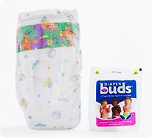
W
hen you’re traveling with your baby, one school of thought is to pack light, since lugging around your little one and probably a stroller and other baby gear is enough already. Another more practical approach, though, is to pack more than you think you’ll need in case you get stuck on the tarmac, your flight or layover turns out to be longer than you thought or who knows? When you’re on the go with your baby, you want to be ready for everything and anything.
Whatever your diaper-bag-packing strategy, diapers take up a lot of packing space in your diaper bag and carry-on. You’ll probably want to have six to eight diapers on hand for any given day trip. But Diaper Buds (www.diaperbuds.com) can help you consolidate. These individual, vacuum-sealed disposable diapers are folded and packaged to 70 percent of their original size. “Diaper Buds aren’t spare tire diapers,” says the product’s co-founder LeeAnn Piazzola of Plainview, New York. They’re premium-quality, private-label traditional diapers that spring back to life when the package is opened. “Our uniqueness is in the packaging,” Piazzola says. (Think shrink wrap.) Diaper Buds come in sizes 2, 3, 4, and 5 (from 12 pounds to 27+ pounds) and retail for $5.99 to $7.70 for a small pack (8 or 9 diapers, depending on the size) and $16.79 to $21.49 for a large pack (24 or 30 diapers, depending on the size). The smaller the diaper size, the more you get per package, for the same price. Wanna give ‘em a try? On Diapers.com, you can buy one Diaper Bud for $2.10. Diaper Buds in larger packages are also available on Diapers.com and Amazon as well as other retailers, such as BuyBuyBaby, Baby Depot and diaperbuds.com. Diaper Buds aren’t cheap. In fact, at 60 to 86 cents per diaper, they’re a splurge. But they could be worth it if, for example, they save you from having to pay a checked baggage fee at the airport because you could cram everything you need into your diaper bag and a carry-on.

Chapter Nine

Diaper Safety Savvy

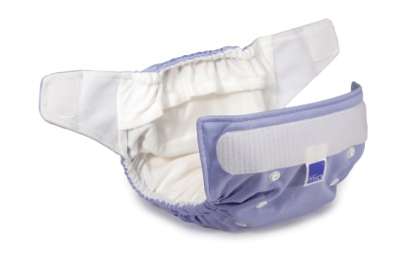
I
t’s peace of mind to know that the disposable and cloth diapers sold in the U.S. are regulated by the Consumer Product Safety Commission’s children’s product safety rules: the Consumer Product Safety Improvement Act (CPSIA) of 2008 and Public Law 112-28.
Diapers must contain no more than 100 parts per million (ppm) of lead and any lead paint and surface coatings can only contain 90 ppm, which applies to things like snaps and fasteners, colorants and PUL. Diapers must also comply with the Wearing Apparel Flammability Standard unless they’re made entirely or contain a combination of acrylic, nodacrylic, nylon, olefin, polyester or wool, which are naturally flame retardant. The standard exists to ensure that the most dangerously flammable fabrics, which are unsuitable for use in clothing, aren’t circulating in the marketplace.
Diaper packages must also have tracking labels that contain certain basic information, including the name of the manufacturer or private labeler, the location of production of the product and detailed information on the manufacturing process, such as a batch or run number, or other identifying characteristics. Tracking labels may help improve the effect-tiveness and response rates for future recalls. No disposable diapers have been formally recalled to date. Meanwhile, if you have a safety complaint about a disposable or cloth diaper, you can report it at www.saferproducts.gov, which alerts your concern to the CPSC and to other parents because the reports are public.
“China Cheapies”
It’s possible to buy cloth diapers that don’t comply with U.S. safety standards. So-called gray-market goods, or “China Cheapies” are available through cloth diaper co-ops, which are typically run by fellow parents. Diaper co-ops place quantity orders directly to cloth diaper wholesalers in China, who sell them to you at a fraction of their retail cost. But some China Cheapies may not be legit. They may be sold, for example, through co-ops without the approval of their U.S. manufacturer. The diapers sold might not be CPSIA compliant either. The materials may not have been tested for flammability. Red flags the diapers you’re buying might be iffy include lack of care labeling, instructions in a foreign language and a super low price. Manufacturer warranties may not be valid if you buy from a co-op either.
Before buying cloth diapers from a diaper co-op, confirm that the diapers are compliant with CPSIA regulations and that the warranties still apply. Avoid buying co-op China Cheapies that are being sold without the manufacturer’s approval. To play it safe, buy co-op diapers from a trusted host and check the manufacturer’s Web page to ensure that the company routinely sells to diaper co-ops.

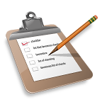
Diaper To-Do List
There are a lot of ways to save on diapers as I’ve outlined in this book. So many, in fact, that you may not know where to begin. I offer these three basic suggestions as starting points:
- Consider using reusable/cloth diapers, if they’re at all a possible fit with your lifestyle. To save the most, try to buy a small stash of used cloth diapers and experiment with styles and types until you’re sold on one or two in particular. Then, go ahead and buy more of what works, either new or used. Review Chapter 5 for money-saving strategies on cloth diapers.
- If reusable/cloth diapers aren’t an option, buy store-brand disposables from Target, Walmart or your local supermarket by using coupons, coupon codes and taking advantage of any available promotions. Buy the smallest count package you can find and see if you like them. If they pass muster (no leaks or irritation), go ahead and stock up by combining as many deals, coupons and promotions as you can find.
- If you want to use brand-name disposables, ditto. Check out different brands until you find one or two you like by buying small-count packages, then go from there. Whether you’re stocking up or experimenting, try the money-saving strategies outlined for disposable diapers in Chapter Two.
Whatever diaper brand, style or type you choose to use, make it your mission to never pay full price.

About the Author

Sandra Gordon
S
andra Gordon writes about shopping, saving money, baby products and safety, parenting, health, and nutrition for books, leading consumer magazines, and Web sites including Parents, American Baby, ShopSmart, ShopSmartmag.org, Prevention, Family Circle and Bed Bath and Beyond. She’s also the author of 11 books, including Save a Bundle: 50+ Ways to Save Big on Baby Gear and Consumer Reports Best Baby Products (the 8th, 9th and 10th editions). Sandra has appeared on NBC’s Today Show and as a baby safety expert on The Discovery Health Channel’s “Make Room for Baby” and for local news programs. She helps new parents gear up for less at:
www.babyproductsmom.com.
Sandra lives in Connecticut with her husband and their two daughters.
Follow Sandra on Twitter @sgordonwriter.com.
Post about this book to Facebook.
E-mail Sandra: Sandra@sandrajgordon.com
Check out Sandra’s professional writer site:
www.sandrajgordon.com.
Read Sandra’s all-round baby-gear-saving book: Save a Bundle: 50+ Ways to Save Big on Baby Gear.
WAS THIS BOOK HELPFUL TO YOU?
PLEASE WRITE A REVIEW ON AMAZON.
THANKS FOR READING!

